A MAJOR PROJECT REPORT
on
Design and Fabrication of Eco-Friendly Bearing Material using Friction Stir Processing
Submitted in partial fulfillment for the award of the degree
of
\BACHELOR OF TECHNOLOGY
in
AUTOMATION & ROBOTICS

Submitted by
Saksham Jha (00719012021)
Rohan Gupta (04519012021)
Shubham Bhardwaj (05119012021)

Under the Guidance of
Dr. Sumit Chaudhary Assistant Professor
Dr. Sonia Dangi

Assistant Professor

UNIVERSITY SCHOOL OF AUTOMATION AND ROBOTICS GURU GOBIND SINGH INDRAPRASTHA UNIVERSITY EAST DELHI CAMPUS
SURAJMAL VIHAR, DELHI-110032
December 2024

DECLARATION

We, Shubham Bhardwaj (05119012021) , Rohan Gupta (04519012021) and Saksham Jha (00719012021) hereby declare that the major project titled “Design and Fabrication of Eco- Friendly Bearing Material using Friction Stir Processing” submitted to University School of Automation & Robotics, Guru Gobind Singh Indraprastha University, East Delhi Campus, Delhi-32 in partial fulfillment of the requirement for the award of the Bachelor of Technology in Automation & Robotics was original and not copied from any source without proper citation. This is further to declare that the work embodied in this report has not previously formed the basis for the award of any Degree, Diploma Associateship, Fellowship or other similar title or recognition.
.

Place: Delhi Name: Shubham Bhardwaj (05119012021)

Rohan Gupta (04519012021)

Saksham Jha (00719012021)

Date: 22 March, 2025

CERTIFICATE

I hereby certify that the major project entitled “Design and Fabrication of Eco-Friendly Bearing Material using Friction Stir Processing”, in partial fulfillment of the requirements for the award of the Degree of Bachelor of Technology in Automation and Robotics, submitted to University School of Automation & Robotics, Guru Gobind Singh Indraprastha University, East Delhi Campus, Delhi- 32 was an authentic record work of Shubham Bhardwaj, Enrolment No. 05119012021 , Rohan Gupta, Enrolment No. 04519012021, Saksham Jha, Enrolment No. 00719012021 and was carried out under my supervision.
It was to further certify that the matter embodied in this report has not been submitted to any other university or institution by her for the award of any other Degree/Certificate elsewhere to the best of my knowledge and belief.

Dr. Sumit Chaudhary Assistant Professor
University School of Automation and Robotics Guru Gobind Singh Indraprastha
University Delhi-110032

Dr. Sonia Dangi Assistant Professor
University School of Automation and Robotics Guru Gobind Singh Indraprastha
University Delhi-110032

ACKNOWLEDGMENTS

We are immensely grateful to our supervisor Dr. Sumit Chaudhary and Dr. Sonia Dangi for his guidance, unwavering support and encouragement. This project work could not have attained its present form, both in content and presentation, without his active interest, direction and guidance. His personal care has been the source of great inspiration to us. He has devoted his invaluable time and took personal care in motivating us wherever we were disheartened.
We are also thankful to Prof. Arvinder Kaur, Dean USAR and Prof. Ajay S. Singholi, Program Coordinator A&R, USAR for their support and guidance, although they had a very busy schedule in managing the corporate affairs.
I am also thankful to my friends and parents for their support. Rest all those directly or indirectly involved.

Shubham Bhardwaj (05119012021)

Rohan Gupta (04519012021)

Saksham Jha (00719012021)

Table of Contents

Declaration i

Certificate ii

Acknowledgment iii
Abstract
- Introduction 1
  - Classification of Composite Materials 2
    - Polymer Matrix Composites 3
    - Ceramic Matrix Composites 3
    - Metal Matrix Composites 4
  - Techniques for Fabrication of Metal Matrix Composite 6
  - Environment Friendly Processes 7
  - Friction Stir Processing 9
    - Types of FSP Approaches 10
    - FSP variables for fabrication of composite 11
    - Applications of FSP 13
- Literature Review 14
  - Major Findings 49
  - Research Gaps 49
- Research Objective 50
- Methodology 53
- Experimentation 54
  - Material and Method used 55
  - Tool for Machining 55
  - Sample Preparation 56
- Research Plan 59
- References 60

List of Figures

Figure 1 Evolution of Composite Material 2
Figure 2 Classification of Composite Materials 3
Figure 3 Schematic Diagram of (a) fibres (b) Whiskers (c) particles reinforced MMCs 4
Figure 4 Techniques used for MMC Fabrication 5
Figure 5 Correlation between Atmospheric CO₂ Levels and GMST Anomalies [66] 8
Figure 6 Processes involved in FSP 10
Figure 7 Groove Filling Method [79] 10
Figure 8 Cover Plate Method [84] 11
Figure 9 FSP variable 11
Figure 10 Tool Shapes [86] 12
Figure 11 Shoulder Geometry [88] 12
Figure 12 Specimen of Cu Plate with grooves 54
Figure 13 Fabricated Tool Profile 55
Figure 14 Dimensions of Tool 56
Figure 15 Muffle Furnace 58
Figure 16 FSP Machine 58
Figure 17 FSP results 58
Figure 18 Labeled Samples for Microstructure 59

List of Tables

Table 1 Comparison Table for MMC Fabrication Techniques 06
Table 2 Review of Fabrication Techniques of various MMCs and their effects on its properties 14
Table 2.1 Latest Developments in FSP 28
Table 2.2 Review of the performance of Cu-based MMCs formed using FSP 40
Table 2.3 Numerical Research on the performance of Cu-based MMCs formed using FSP 46
Table 3 Process Parameters during FSP 57

Design and Fabrication of Eco-Friendly Bearing Material using Friction Stir Processing

Abstract

The application of friction stir processing (FSP) in fabricating copper-based metal matrix composites (Cu-MMCs) is critically evaluated in this review, with additional insights on aluminum and magnesium MMCs provided to study the characteristics of the FSP process. The influence of key FSP parameters - tool geometry, rotational speed (550–4500 RPM), and traverse speed (10–160 mm/min) - on microstructural refinement, reinforcement dispersion, and mechanical performance is systematically analyzed. Particular focus is placed on Cu-MMCs reinforced with SiC, Al₂O₃, TiC, and MWCNTs, where improvements in hardness, tensile strength, and wear resistance are achieved through grain refinement and enhanced interfacial bonding. Multi-pass processing, cryogenic cooling, and inert gas shielding are further explored as generally used strategies to reduce oxidation and enhance composite integrity. These findings are expected to contribute to the exploration of FSP as an eco-friendly and scalable method for more advanced applications.

Introduction

Various industries have significantly flourished by the advent of composite materials due to their advanced properties. Composite materials, formed by combining two or more distinct materials, aim to achieve improved mechanical, physical, thermal, and electrical characteristics. Typically, they consist of a continuous phase called a matrix, generally made from ceramics, metals, or polymers, and one or more discontinuous phases known as reinforcements, which include fibres or particles. The matrix helps in keeping the reinforced particles in place and the reinforcements help in tailoring the physical and mechanical characteristics of the said material [1].
Although the concept of composites is far from new. Composites have been around since 10,000 BC, with one of the earliest examples being straw bricks used in construction, mainly due to their low-density and cooling-energy demands. Further, another significant example of composite materials dates back to around 1200 BC with the Mongolian invention of the composite bow while literature dates back its existence as early as 3000 BC. These bows, made from various materials, including wood, horn, sinew, leather, bamboo, and antler were powerful enough to shoot arrows up to 1.5 kilometres.
The history of modern-day composites started roughly around the 1930s. Modern polymer composites, driven by material shortages during World War II, were lightweight and strong materials essential for advanced military applications, particularly in fighter planes[2]. Non-metallic materials, required for housing electronic radar equipment, led to the use of Glass Fibre Reinforced Plastics, with phenolic resins as the matrix material. Utilisation of composites has been prevalent in modern day-to-day life. Concrete, for example, is a composite made from gravel, sand, and cement, which when combined with steel, forms structural components, commonly used in construction. Wood, on the other hand is another commonly used composite, constituting cellulose and lignin, has evolved into advanced forms like plywood and particle-board find their applications in building materials and furniture.
Utilisation of composites may be termed as ubiquitous, given its presence in human muscles, structured in layers with fibres oriented at various angles and concentrations. This assortment creates a strong, efficient, and adaptable system that gives strength to the bones and vice versa, resulting in a distinctive structural synergy. Bone itself is a composite structure made up of a mineral matrix that holds the collagen fibres together.

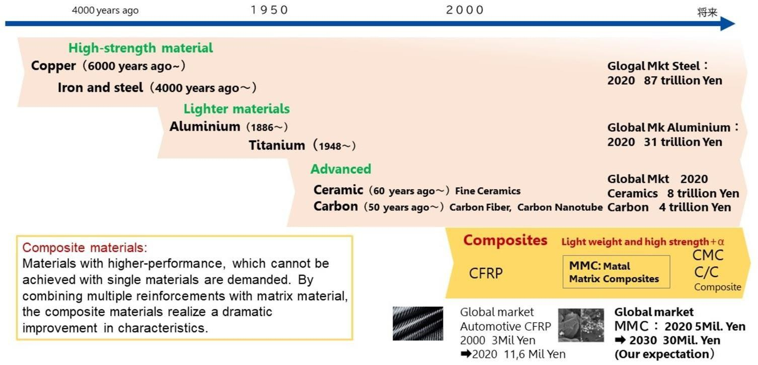
Future
Figure 1 Evolution of Composite Materials [3]
Since then, composites have been recognized as exceptional materials, meticulously designed and manufactured for a wide range of applications, both industrial and non- industrial, including aerospace, automotive, and sports equipment.

Classification of Composite Materials


Composite materials represent a versatile class of materials distinguished by their ability to combine different materials to enhance performance. They can be classified based on several factors as shown in Figure 2.
Composite
Materials
Based on Scale
Based on
Reinforcement
Biocomposites
Based on
Matrix Material
Nano-
Composites
Fibres
Reinforced
Sheet Molded
Particles
Reinforced
Polymers
Ceramic
Metals

Figure 2 Classification of Composite Materials

1.1.1 Polymer Matrix Composites

PMCs consist of a matrix made from either thermosetting plastics (like, epoxy, polyester and phenolic resins) or thermoplastic plastics (like, polyamide,polyimide, polypropylene, polycarbonate, etc.), reinforced with materials such as glass fibres, Kevlar, carbon fibres, or metal fibres [4,5]. During their preparation, thermosetting plastics are often preferred over thermoplastics due to thermal resistance and enhanced strength offered by them.
Thermosets are created by combining a resin with a hardener, leading to the formation of a solid, robust material. A common technique for fabricating the laminar structure of PMCs involves layering thin sheets of fibre and polymer, then bonding them together to achieve the required thickness [6]. Furthermore, PMCs are regarded as cost-effective composites due to their ease of handling and straightforward fabrication processes, outstanding chemical and corrosion resistance, making them suitable for a diverse array of applications, including aerospace, automotive, and sports equipment [7,8].

Ceramic Matrix Composites

CMCs are sophisticated materials consisting of fibres made from carbon, silicon carbide (SiC), aluminium oxide (Al₂O₃), and silicon nitride (Si₃N₄), embedded within a ceramic matrix [9]. Unlike traditional metal or polymer composites, where the matrix typically fails first under load, CMCs which are specifically engineered to mitigate the inherent brittleness of monolithic ceramics perform the exactly reverse phenomenon, earning them the designation of inverse composites.
The fabrication of CMCs employs specialised processing techniques, including gas-phase and liquid-phase methods, which allow for the formation of the matrix around the fibres using gaseous or liquid precursors [10]. This innovative approach significantly enhances the toughness of the material, despite the brittleness of its individual components. CMCs are particularly advantageous in extreme conditions, and their Tribological properties such as friction, lubrication, and wear are essential to their overall performance [11].

Metal Matrix Composites

MMCs are advanced materials engineered such that they combine two or more materials, typically featuring a ductile material or an alloy metal matrix such as aluminium (Al), magnesium (Mg), or titanium (Ti) and reinforcing materials,either metallic or non-metallic, including ceramic carbides (e.g., SiC, B₄C), oxides (e.g., Al₂O₃, SiO₂), nitrides (e.g., AlN, Si₃N₄), or elemental materials (e.g., carbon, silicon) [12]. These reinforcements can take the form of continuous or short fibres, particles, or whiskers as shown in Figure 3 [13], [14].







(a) (b) (c)

Figure 3 Schematic Diagram of (a) fibres (b) Whiskers
(c) particles reinforced MMCs
MMCs present several benefits as compared to conventional monolithic non- reinforced materials, such as improved Young’s Modulus of elasticity, enhanced specific stiffness, superior wear resistance and strength, and a greater thermal stability, damping capabilities, tailored by adjusting the proportions, distribution, and types of the constituent materials [15], [16]. Initial research on MMCs, as done by Seleznev et al. concentrated on using continuous fibre reinforcements to improve thermal and mechanical performance [17]. However, the complexities of fabrication, high fibre costs, and manufacturability issues limited their widespread application which prompted the shift towards discontinuously reinforced MMCs, such as short fibres, SiC whiskers, and SiC particles [18].
Applications of MMCs have expanded significantly in industries where their offered combination of lightweight and high performance material is invaluable. For example, Al–4.5%Cu-based MMCs are extensively utilised in aerospace and automotive industries for components such as turbine blades, structural elements, and automotive parts like brake discs and engine components, where the material's high strength, long-term durability, and ability to withstand thermal fatigue are crucial [19,20]. Additionally, the ability to tailor MMCs for specific properties continues to make them attractive for the latest engineering challenges such as robotics, emerging electronic items and many more.

Techniques for Fabrication of Metal Matrix Composite

Fabrication methods for MMCs are categorised into four primary types as shown in Figure 4. And Comparison Between them is given in Table 1.


Fabrication
Methods
Liquid-State
In-Situ
Processes
Deposition
Techniques
Solid-State
Stir Casting
Infiltration
Diffusion
Bonding
Sinter-
Forging
Gas Pressure
Infiltration
Squeeze
Casting Infiltration
Pressure Die
Infiltration
Figure 4 Techniques used for MMC Fabrication

The following table highlights some of the main fabrication techniques utilized in the manufacturing of composite materials, identifying their state of fabrication (liquid or solid), major strength, and main weakness. These techniques differ with respect to process complexity, cost, mechanical performance, and generality to various material systems. Knowledge of each technique's strengths and weaknesses is critical in the choice of the optimal method of use in various engineering applications.

Table 1 Comparison Table for MMC Fabrication Techniques

Technique | Fabrication State | Key Advantage | Main Drawback
Stir Casting | Liquid | Cost-effective, scalable | Uneven reinforcement distribution
Infiltration | Liquid | Good for complex shapes, high density | High pressure/temperature  needed
Diffusion Bonding | Solid | Strong bonds, fine microstructure | Slow process, costly
Sinter Forging | Solid | High strength, good porosity control | Complex equipment required
In-Situ Processes | Varies | Excellent matrix- reinforcement bonding | Difficult to control final properties
Deposition Techniques | Solid | High precision, surface quality | Expensive, thin layers only

The comparison of various Metal Matrix Composite (MMC) fabrication techniques reveals key insights into their respective advantages and drawbacks. Stir casting, a liquid-state fabrication method, stands out for being cost-effective and easily scalable; however, it often faces challenges with uneven reinforcement distribution, which can compromise the uniformity of the final composite. Infiltration,

another liquid-state technique, excels in producing complex shapes with high density, though it demands high pressure and temperature, making the process energy-intensive. Among the solid-state fabrication methods, diffusion bonding delivers strong bonds and a refined microstructure, enhancing mechanical properties, but it is slow and costly due to its precision requirements. Similarly, sinter forging offers excellent strength and porosity control, though it depends on sophisticated and expensive equipment. In-situ processes, which vary depending on the synthesis approach, enable superior bonding between the matrix and reinforcement but pose difficulties in controlling the final properties of the composite. Lastly, deposition techniques achieve high precision and excellent surface properties, making them ideal for coatings and thin layers, though their high cost and limited scalability remain significant drawbacks. This comprehensive evaluation highlights that the choice of MMC fabrication technique should align with specific project goals, balancing factors like cost, precision, scalability, and desired material properties.

Environment Friendly Processes

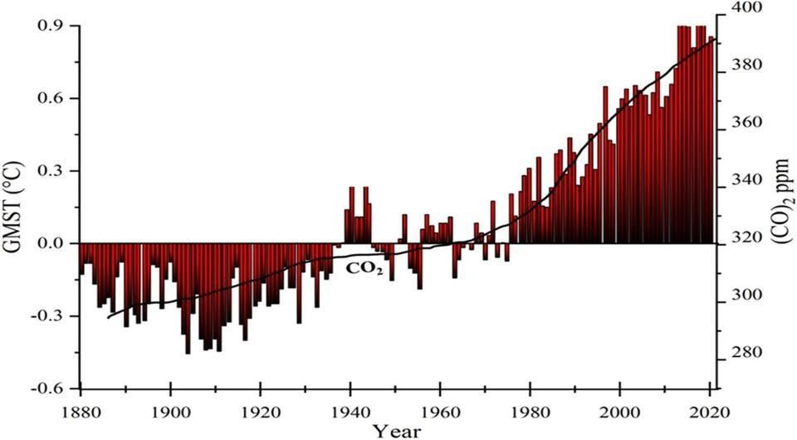
In recent years, the focus on environmentally sustainable processes for the preparation of MMCs has gained significant traction. Traditional MMC fabrication processes, such as powder metallurgy, stir casting, and liquid metal infiltration, often require high energy inputs and involve non-renewable resources. These methods generate greenhouse gases and by-products, contributing to environmental degradation.
Figure 5 Correlation between Atmospheric CO₂ Levels and GMST Anomalies [21]
Alternative approaches such as FSP have emerged as more environmentally friendly options which reduce energy consumption, minimise waste, and enable the recycling of materials like copper, aluminium and magnesium alloys, which are commonly used matrices in MMCs [22,23].
For instance, FSP is a solid-state process that avoids melting, significantly reducing the energy requirements compared to traditional liquid-state methods [24]. Additionally, MMCs incorporating green reinforcements, such as fly ash and agro-waste like rice husk ash, further enhance sustainability [25]. These eco-friendly reinforcements are not only cost-effective but also reduce reliance on limited natural resources [26].

Friction Stir Processing

Friction Stir Processing (FSP) is a solid-state technique derived from Friction Stir Welding (FSW), developed by The Welding Institute in 1991 [27]. In FSP, a non-
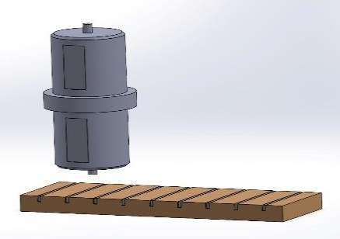
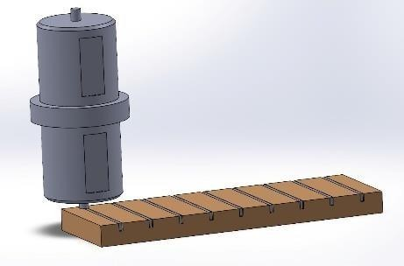
consumable tool with a rotating pin and shoulder generates frictional heat that softens the material without melting it. The process involves plunging the tool into the base material, creating localised plastic deformation and mixing [28-30]. This can be seen through the Figure 6 below.

Tool Probe

Workpiece

Tool rotating clockwise and going downwards

Downward Force
(a) Rotating tool before (b) Tool pin contacts the plate w/p plate contact. and produces heat from
friction.
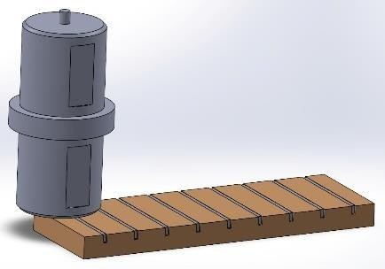
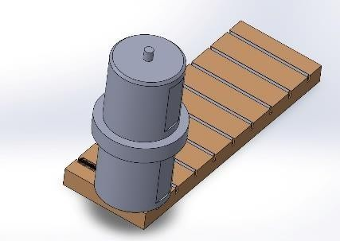
(c) The shoulder contacts the w/p, (d) The w/p moves towards the penetration and frictional heat rotating tool, producing a fully increases. Recrystallized fine grain.

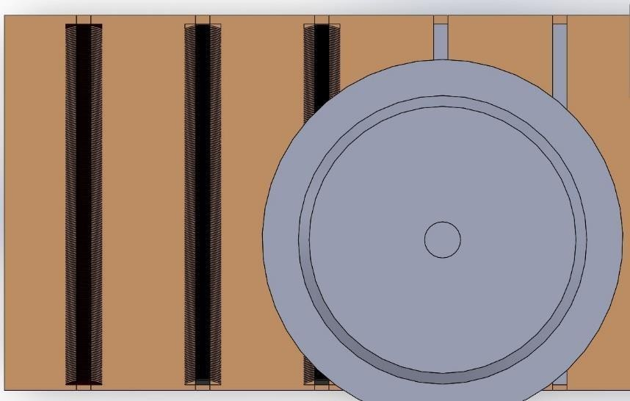

Direction of Workpiece Traversal

(e) Top view of the produced workpiece plate
Figure 6 Processes involved in FSP

As the tool traverses the material, it modifies the microstructure, resulting in grain refinement and the incorporation of secondary phase particles in the stir zone (SZ), which enables the fabrication of composite materials [31,32].

Types of FSP Approaches

Several techniques have been developed to introduce reinforcement particles in the metal matrix during FSP. Key methods include:
- In the Groove Filling approach, as shown in Figure 7, a groove is machined on the material's surface and filled with reinforcement particles. The tool traverses the groove, mixing the particles with the base material, as demonstrated by Mishra et al. on SiC-reinforced aluminium and other composites [33].
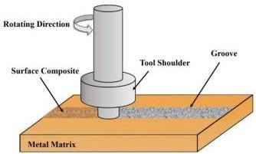
Figure 7 Groove Filling Method [34]

- Drill-Hole Method involves drilling small holes in the base material, filling them with reinforcement, and processing the material with FSP. The process results in uniform particle distribution, as shown by Dixit et al. in composites like NiTi-reinforced aluminium [36-39].
In a further application of this method, a thin sheet used to cover the groove in this way reinforcement is not ejected from the groove, referred to as the Cover Plate method as shown in Figure 8.
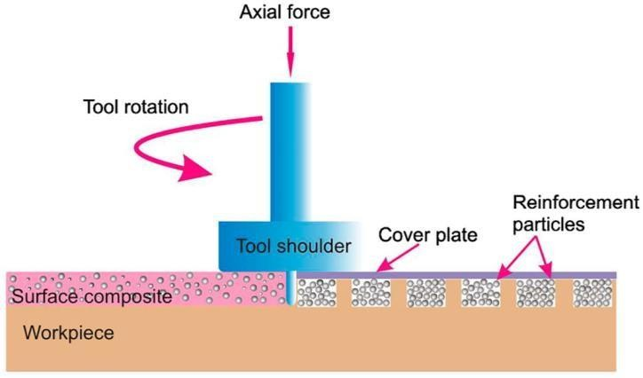
Figure 8 Cover Plate Method [40]

FSP variables for fabrication of composites

The effectiveness of FSP largely depends on 3 variable process parameters such as tool geometry, machine variables and numbers of passes as shown in the Figure 9.



FSP variables
for fabrication
of composite
Tool
Geometry
Machine
Variables
Number of
passes
Shoulder
Geometry
Probe
Geometry
Tool Rotation
Speed
Tool Traverse
Speed
Tool Tilt Angle
Plunge Depth
Direction

Figure 9 FSP variable

The shape of the tool pin- cylindrical, threaded, or tapered as shown in Figure 10, greatly influences material flow. For example, threaded pins improve the downward material flow and reduce the clustering of reinforcement particles,while cylindrical pins result in simpler material flow patterns [45].
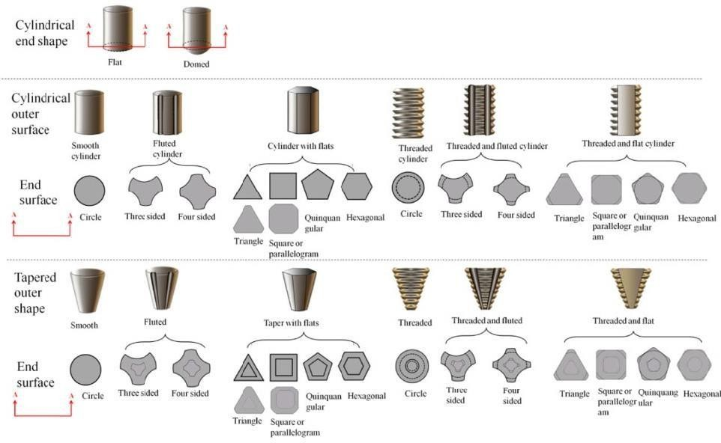
Figure 10 Tool Shapes [46]

The tool's shoulder is primarily responsible for generating frictional heat and containing the softened material. Several shoulder geometries have been shown in the Figure 11. Concave shoulder designs are commonly used to trap material
beneath the tool and facilitate better mixing, leading to improved mechanical properties [47].
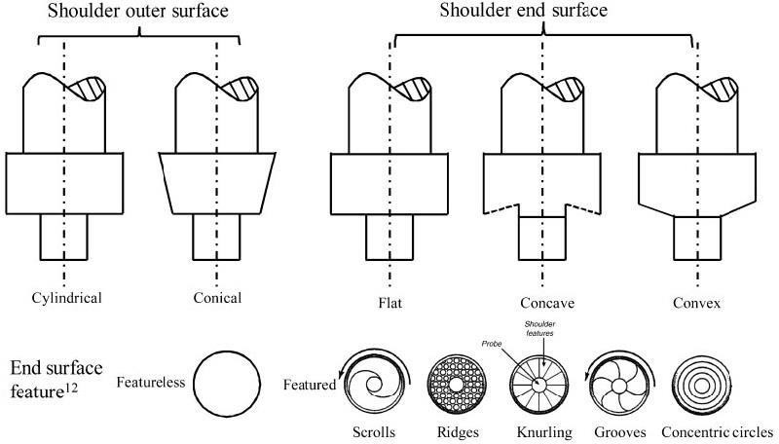
Figure 11 Shoulder Geometry [48]

A small tilt angle (typically 1-3 degrees) ensures optimal downward pressure during FSP, enhancing the consolidation of the material and improving particle distribution. A controlled tilt angle is crucial for ensuring uniform microstructure across the stir zone [49,50].
These variables affect heat generation, material flow, and grain size and help achieve defect-free composites with uniform particle distribution.

Applications of FSP

FSP has numerous applications due to its ability to refine microstructures and enhance material properties. It is particularly useful in:
- Surface Metal Matrix Composites (SMMCs) Fabrication: FSP has been successfully used to fabricate SMMCs, such as aluminium alloy composites reinforced with SiC and Al₂O₃ particles [51]. These composites demonstrate improved mechanical properties like wear resistance, ductility, and fatigue strength [52].
- Nanocomposites Fabrication: FSP has been used to produce nanostructured materials, such as composites reinforced with carbon nanotubes (CNTs) and other nanoparticles [53]. These materials exhibit enhanced mechanical and thermal properties due to the fine dispersion of nanoparticles [54,55].
- Grain Refinement: FSP has emerged as an effective technique for refining grain size in various materials, including aluminium and magnesium alloys, leading to improved strength, toughness, and corrosion resistance. It has been applied to both cast and wrought alloys [56,57].
- Elimination of Casting Defects: FSP can be used to homogenise the microstructure of cast alloys by breaking down the dendritic microstructure and distributing reinforcement particles evenly, thereby improving the material’s overall strength and ductility [58,59].

Literature Review

The table below delves into the various fabrication methods employed in metal matrix composite (MMC) MMCs are advanced materials engineered such that they combine two or more materials, typically featuring a ductile material or an alloy metal matrix such as Aluminium (Al), magnesium (Mg), or titanium (Ti) and reinforcing Materials ,either metallic or non-metallic, including ceramic carbides (e.g., SiC, B₄C), oxides (e.g., Al₂O₃ , SiO₂), nitrides (e.g., AlN , Si₃N₄), or elemental materials (e.g., carbon, silicon) production and how each process affects the resultant material properties. Through comparison of both solid-state and liquid-state processes, the research points out the effect of fabrication on microstructure, mechanical strength, thermal stability, and overall performance of MMCs in various material systems.

Table 2 Review of Fabrication Techniques of various MMCs and their effects on its properties

S. No. | Researchers | Material Composition | Mechanical Properties | Applications
1. | H. Zuo et al. [60]; | Carbon matrix | Wettability | Electrical
 | 2021 | (consisting of | improvement, | Contacts, Thermal
 |  | pitch coke | improving | Management
 |  | powder, needle | copper | Systems, and
 |  | coke powder, | infiltration and | Bearing Materials
 |  | carbon black, | interfacial
 |  | and flake | bonding
 |  | graphite)/copper | Increase in
 |  | matrix doped | Mechanical
 |  | with 0.6, 1.2, 2.5, | Strength
 |  | or 3.0 wt. % | (Flexural
 |  | boron. | strength and
 |  |  | compressive
 |  |  | strength).
 |  |  | Increase in
 |  |  | Electrical
 |  |  | Conductivity.
2. | E. Hong et al. [61]; 2011 | Composites of | Uniform | PDC Drill Bits of
 |  | Cu-alloy matrix | distribution of | Oil/Gas Industry
 |  | (comprising 14– | composition
 |  | 16 wt.% nickel, | with no cracks
 |  | 7–9 wt.% zinc | or delamination
 |  | and 23–25 wt.% | Increased
 |  | manganese) or | Hardness,
 |  | WCp | Enhanced wear
 |  | (Kennametal) | resistance and
 |  | and tungsten | reduced amount
 |  | carbide | of ploughing
 |  | (Taegutec) with | wear on Cu-
 |  | or without | alloy matrix
 |  | indium as | although the
 |  | dopant. | wear rates
 |  |  | increased with
 |  |  | increasing
 |  |  | sliding distance.
 |  |  | Higher
 |  |  | coefficient of
 |  |  | friction in
 |  |  | composite
 |  |  | without indium.

3. | S. O. Akinwamide et al. [62]; 2021 | Aluminium alloy (composition includes Al, Si, Fe, Cu, Mn, and Mg, with  aluminium as the balance) reinforced with Silicon Carbide (SiC) Powder (Particle size 7  µm, 99.21%  purity) Ferrotitanium (TiFe) Powder (Particle size 176  µm, 56.55% Fe  and 41.67% Ti) | Tensile strength improvement Improvement in Hardness Reduction in wear rate | Aerospace, Automobile, and Military
4. | A. O. Mosleh et al.  [63]; 2022 | 198 Al based Alloy of anti-  friction Element combinations |  | Bearing
5. | Y. Pazhouhanfar et al. [64]; 2018 | Al6061  aluminium alloy matrix reinforced with TiB2 ceramic particles (3%,  6%, and 9% by weight). | Hardness Increased due to Grain refinement.  Tensile Strength Improved up to 29.2%  Ductility slightly reduced Flexural Strength  Increased | Aerospace, defence, and automotive industries, Cutting tools, impact- resistant components, crucibles, and wear-resistant coatings
6. | V. K. Sharma et al. [65]; 2019 | Al-6061 alloy Matrix reinforced with Rare-earth particulate (CeO₂) (0.5 wt.  % - 2.5 wt. %)  and Secondary ceramic reinforcements like SiC (Silicon  Carbide) and | Grain Refinement, Flexural Strength Increased by 44.76%,  Improved Wear Resistance, Tensile and Impact Strength Improved,  Significant | Aerospace Industry, Automobile Industry, Defence Applications and other Industrial Applications where wear and hardness are critical.

 |  | Al₂O₃ (Alumina) ranging from 2.5 wt. % to 7.5 wt.  %. | improvement in Vickers micro hardness, Higher amounts of CeO₂ (>2.5 wt. %) increased porosity and diminished mechanical performance.
7. | P. P. Awate et al. [66]; 2023 | Al6061 alloy Matrix reinforced with Graphene Nano platelets (GNPs) in weight  fractions of 2%,  4%, 6%, and 8%. | Significantly improved tensile strength Enhanced wear resistance Uniform distribution of graphene with low porosity | Aviation Industry, Automobile Industry
8. | B. Das et al. [67]; 2016 | Al-4.5%Cu  matrix reinforced with TiC to produce Al-4.5%Cu- 5%TiC MMC | Enhanced Micro- Hardness, Improved Toughness, Increased UTS, Fine Microstructures  with Uniform Distribution | Aerospace Industry, Automobile Sector, Defence Equipment, Electronics, Tool Manufacturing
9. | T. Tamilanban et al. [68];2021 | Aluminium alloy 6061 reinforced  with 12% Silicon Carbide (SiC) by vol., 4%  Magnesium (Mg) by wt. and 2% Copper (Cu) by weight. | Superior Tensile strength, Increased hardness, Improved wear resistance, Higher coeff. of friction,  Reduced ductility | Aerospace Industry and Automotive Industry
10. | K. Praveen Kumar et al. [69]; 2015 | MMC with Cu 4.38%, Mg  1.52%, Si 0.4%,  Zn 0.13%, Fe  0.02%, Cr  0.12%, and  balance Al reinforced with Al–20Cu–10Mg  high entropy | Improvement in Hardness Increase in Tensile Strength Improved Young's modulus | Automobile and Aerospace Industries

alloy (125 µm)
5%, 10% and
15% by wt.
11. | V. Krishna Mamidi et al. [70]; 2023 | Titanium Diboride reinforced magnesium composites | Homogeneous distribution Enhanced hardness, tensile strength and wear resistance Increased corrosion resistance. | Automobile and Aerospace industries
12. | K. N. P. Prasad et al.[71]; 2018 | LM6 Aluminium alloy (chemical composition: 12.2% Si, 0.62%  Mn, 0.32% Fe,  balance Al), reinforced with fly ash (5% to 12.5% variable by wt.)  The chemical composition of fly ash includes 63.96% SiO2,  25.5% Al2O3,  6.07% Fe2O3,  CaO, and trace amounts of other elements | Increase in hardness Enhanced abrasive wear resistance Reduced porosity | Automobile Components and Aerospace Engineering
13. | V. Pandian and S. Kannan [72]; 2022 | Aerospace-grade Aluminium Alloy 7075 (AA7075),  composed mainly of 90.1% Al, 5.47%  Zn, 2.19% Mg,  1.48% Cu;  reinforced with other elements like Cr, Fe, Mn, Si, Ni, and Sn | Increase in  hardness and Impact Strength Improved wear resistance Improved Corrosion Resistance | Aerospace Applications
14. | M. R. Pattnayak et al. [73]; 2020 | AMCs  reinforced with aluminium alloys (AA2024,  AA6061) and | Increased load- carrying capacity and  Stability Enhanced | Automobile and Aerospace industries (high-  speed bearings for high-speed

 |  | fibres (SiC or Al2O3) |  | Strength (tensile strength, fatigue resistance, and wear resistance) in AMCs |  | application like Turbomachinery and Aerospace Propulsion Systems that  require high  stability, low friction, and oil- free operations).
15. | C. S. Kim et al. [74]; 2017 | Aluminium (both pure and alloyed, including Al6061)  reinforced with micron-sized particles (like SiC, Al₂O₃) and Nano-sized particles (like  Al₂O₃, B₄C,  TiB₂) for  MMNCs |  | Increased Yield strength and UTS, Improved surface hardness and wear resistance, Improved Wear and Corrosion Resistance, Reduced Ductility |  | Aerospace Industry, Automotive Industry, Military and Defence, Electronics and Microelectronics
16. | V. R et al .[75]; 2023 | Magnesium (Mg) and its alloys Matrix Material reinforced with Hydroxyapatite (HA) particles, Tricalcium phosphate (TCP) and various alloying elements like Ca, Zn, Mn, and Sn. |  | Enhanced compressive strength, corrosion resistance, and grain refinement Improved compatibility with biological tissues, promoted osteo- conductivity and bone regeneration Improved Corrosion  Resistance in physiological environments but Rapid corrosion in high-chloride environments |  | Biomedical Applications including Orthopaedic bone implants and Dental Applications, Aerospace Industry and Automobile Industry
17. | J. Woźniak et al .[76]; 2022 |  | Aluminium alloy AA6061 matrix reinforced with  7.5 vol.% SiC particles |  | Higher micro hardness at the edges compared to the centre, Higher dislocation density, Texture weakening near the edge of rods, hardness  variation across its cross-section | Aerospace and Automobile Industry
19. | L. Guirong et al. [78]; 2021 |  | Aluminium (Al) matrix reinforced with FeCoNi1.5CrCu, with atomic ratio 1:1:1.5:1:1 for  Fe, Co, Ni, Cr, and Cu. |  | Improved Nano- hardness Betterment in elastic modulus, reflecting strong interfacial bonding.  Compressive Strength improvement and good toughness.  Above 480°C, the material exhibited brittle behaviour and reduced its ductility | Aerospace Structures, Automobile Components and Electronics
20. | S. Sharma et al .[79]; 2021 |  | AA2024-T351 (Al–Cu–Mg–  T351) Alloy reinforced with |  | Increased Hardness,  Improved UTS, Improved | Automotive, aerospace,  Electromechanical Industry,

 |  | MWCNTs in 0.1–0.5 wt. % | ductility and resistance | nonlinear optics,  sensors, and high- strength devices.
21. | J. Narayana Kamineni  et al. [80]; 2023 | Nano borosilicate (NBS)  reinforced AZ91D  magnesium alloy | NBS was uniformly distributed in AZ91D alloy without  forming residual pore Improvement in hardness Improvement in Tensile properties  Load bearing capacities of the reinforcing particles as well as the formation of transfer layers  between the matrix and the reinforcement particles wear  resistance improved.
22. | V. Pandian et al. [81]; 2020 | Aluminium alloy 7075 with chemical composition (in wt. %) of 90.1% Al, 5.47% Zn,  2.19% Mg,  1.48% Cu,  0.23% Cr, 0.17%  Fe, 0.15% Mn,  0.084% Si,  0.029% Ti,  0.002% Ni,  0.0009% Pb,  0.0005% Sn | Measured density was  higher than theoretical density, and porosity  was below 2% Betterment in interfacial bonding and wettability.  Increased hardness Increased corrosion resistance | Aerospace Industries, Most Structural Components, Inner Frame Members, Fuselage Tanks, and Fasteners

23. | J. Chen et al. [82]; 2015 | Copper (Cu) powder of high purity reinforced with AlCoNiCrFe particles, synthesized from equi-atomic elemental powders of Al, Co, Ni, Cr, and Fe (99.7%  purity, particle size <60 µm). | Yield Strength Improvement Ductility Decrease  No Grain Growth or Intermetallic Formation | Aerospace Industry, Electronics
24. | D. K. Koli et al . [83]; 2015 | AMCs  reinforced with Micro/Nano-SiC (Silicon Carbide)  Al₂O₃ (Alumina) B₄C (Boron Carbide)  TiB₂ (Titanium Diboride)  ZrO₂ (Zirconia) Graphite particles | Increased hardness and UTS.  Tensile strength improved, though elongation decreased slightly.  Wear resistance increased through thermal aging, improving hardness and abrasion resistance.  The fatigue life  of AMCs improved. | Automobile and Aerospace Industries
25. | T. Futami et al.[84]; 2008 | Electrolyte Cu reinforced with graphite | Vickers and True hardness was recorded. True hardness more at Press  Surface than Edge surface | Electrical Brush and Bearing
26. | C. M C et al. [85]; 2024 | Al-Si-Mg alloy (Al-6.7Si-  0.2Mg) contains Al, Si, Mg  reinforced with | Increased hardness and UTS  Wear Resistance | Aerospace Industry

10 wt.% Silicon
Nitride (Si₃N₄) particles (25 μm)
27. | Z. Yuan et al. [86]; 2020 | 5052 aluminium alloy powder (<50 µm) matrix with a chemical composition of  2.2–2.8% Mg,  0.4 % Fe, 0.15–  0.35% Cr, 0.25%  Si, 0.1% Mn,  0.1% Zn, 0.1%  Cu and balance Al reinforced with Al0.6CoCrFeNi | Hardness increased Improved Young’s modulus of Elasticity | Automobile and Aerospace Industries
28. | Y. Liu et al.[87]; 2021 | Aluminium (Al) powder with a purity of 99.9%  (80 µm)  reinforced with CoCrFeNi (15–  52 µm)  surrounded by a shell of mixed Co, Cr, Fe, Ni, and Al elements, with the shell thickness around 16 µm | Improved hardness Superior Nano indentation, creep resistance, with the shell displaying higher resistance to deformation than the core Compressive Strength improved and  decrease in ductility | Chemical Processing, Automobile and Aerospace
29. | Z. Yuan et al .[88]; 2019 | Co Cr Fe Mn Ni high-entropy alloy | Increased strength Increased wear and creep  Resistance
30. | S. Li, Y. Li, H. Guo, Z.  Wen, and Z. Zhu [89]; 2022 | Al-Sn alloy | Improved Corrosion resistance Refined grain size  surface properties recorded for 30Hz EMS  sample | Bearing

31. | A.Kumar et al.[90]; 2021 | Al7075 alloy reinforced with Marble Dust | Values of Optimized mechanical and physical  Strength are recorded | Bearing and structure
32. | M. C. Lucchetta et al. [91]; 2019 | Al–Sn–Cu alloy | Optimized parameter for melt-Spinning sample recorded and Hardness relation with Al grain size improved wettability | Bearing
33. | T. Iwata et al.[92]; 2021 | Al alloy | Improved seizure and friction properties against Steel Counterpart | Bearing For Automobile
34. | S. N. Alhajeri et al .[93]; 2016 | Al-6061 metal matrix composite reinforced with 10 vol. % Al2O3 particles. | Strain hardening of MMC  without notable recovery, Aluminium matrix grain size decreased from ~35 μm to  ~170 nm after 10 turns, Micro hardness at fractional numbers of turns (N ≤ 1 turn) increases linearly from  ~62 Hv at the centre of the disk to ~140 Hv near the edge, whereas for upto N = 10 turns, the micro  hardness | Aerospace and Automobile Industries, Defence and Structural Applications, Precision Engineering and Tooling

becomes more homogeneous with a saturation of ~170 Hv; at the outer region of the disk at equivalent strains above
~50.
35. | Y. Pan et al .[94]; 2017 | Magnesium alloy (AZ31) matrix reinforced with CFRP (Carbon Fibre Reinforced Polymer), consisting T300  carbon fibre and 648 epoxy | Lower corrosion rates, Galvanic Corrosion Mitigation in MAO coated composites, Weight Reduction | Marine and Coastal Structures, Aerospace Industry, Automobile Components, Renewable Energy Systems
36. | X. Hao et al .[95]; 2019 | Fibre metal laminates (FMLs): Zn-Al  alloy (8% Al by weight) matrix reinforced with continuous carbon fibre  (T700SC) and  AZ31 Mg alloy sheet layers | Tensile strength improved by 103%, Elastic Modulus improved by 41%, Strain to Failure Increased, The formation of MgZn₂ at the Mg/Zn-Al interface provided excellent  metallurgical bonding | Aerospace Industry and Automobile Industry
37. | R. Jamaati et al .[96];  2012 | Commercial purity aluminium sheets (Al 1100) reinforced with Aluminium oxide (Al₂O₃) (<50 µm) varied  between 0% and  1.0% by wt. | Increased Micro hardness, Increased Tensile Strength (UTS), Reduced Ductility | Aerospace, Automotive, and Electronic industries

38. | V. S. Aigbodion et al .[97]; 2024 | Magnesium- carbon nanotube (Mg-CNT)  nanocomposites (0.5 wt.% CNTs)  reinforced with 0, 2, 4, and 6 wt.% hexagonal boron nitride (h- BN) | Corrosion Resistance Microstructure Improvements at 4 wt. % h-BN and deterioration at 6 wt. % h-BN. Wettability and Mechanical  Strength enhancement | Aerospace, Automobile, and Electronics industries
39. | A. Deshpande et al.  [98]; 2019 | - Al6061  aluminium alloy  - Copper | Copper: Ductility improvements Al6061:  Enhanced Grain Refinement and Microstructural Uniformity | Wire bonding in electronics and microelectronics, Aerospace and Automobile Industry
40. | P. R. Subramanian et al [99]; 1998 | Titanium alloys, Ti–6Al–4V and orthorhombic titanium aluminide (Ti– 22Al–23Nb)  reinforced with SiC fibres (Textron SCS-6) | Improved Specific Strength and Stiffness, Homogeneous Microstructures, Low Impurity Levels, Matrix Cracking, Porosity Challenges | Aerospace structural applications
41. | R. S. Mishra et al [100]; 1999 | 7075 Al Alloy | Stress-Strain rates were  recorded for super plasticity forming and forging
42. | K. E. C. Vidyasagar et al .[101]; 2021 | Radial ball bearings include  Bearing steel (EN31) for the | Frictional Torque  reduction Vibration | Bearings in Heavy-Load  Transfer Robots, Conveyor Belts

 |  |  | outer race, inner race, and the balls and  Polyamide for the cage holding the metallic balls. | reduction Temperature reduction  Wear Resistance improved | and for Medical Implants (e.g., Spinal and Hip Load-Bearing Components)
43. | N. C. Ramgopal | Et al.[103]2022 | AA7475 |  | Aerospace
 |  |  | aluminium alloy |  | Industry,
 |  |  | hybrid |  | Automobile
 |  |  | composites |  | Industry, Defence
 |  |  | reinforced with |  | and Tooling
 |  |  | Boron Carbide
 |  |  | (B₄C)
44. | A. Shafiei-Zarghani et al. [103]; 2009 |  | 6082 Al alloy | Improved Wear | Aerospace | and
 |  |  | reinforced with | and Hardness, | Automobile
 |  |  | Nano particles | Micro hardness | Industry
 |  |  | Al | recorded,
 |  |  |  | improve with
 |  |  |  | multiple passes
45. | G. M. Gençer [104]; |  | Aluminium alloy | Exponential | Automobile
 | 2024 |  | AA1050-H14 | Increase in | Industry
 |  |  | reinforced with | hardness of SZ
 |  |  | graphite | low wear with
 |  |  |  | increasing
 |  |  |  | Graphite
 |  |  |  | content
46. | H. Sarmadi et al  [105];2013 |  | Cu Plates | Prevent
 |  |  |  | Clustering of
 |  |  |  | Particles in
 |  |  |  | composition
 |  |  |  | Friction
 |  |  |  | coefficient
 |  |  |  | decrease up to
 |  |  |  | 25% graphite
 |  |  |  | Increase in
 |  |  |  | Graphite
 |  |  |  | increased
 |  |  |  | delamination
 |  |  |  | and Decreased
 |  |  |  | Adhesive Wear
47. | A. Maqbool et al. |  | Casted WE43 | Improved | Aeronautical
 | [106]; 2023 |  | Mg alloy | Ductility and | Industry,
 |  |  | reinforced with | Strength | Automobile
 |  |  | Ti, Al, Sn |  | Industry | and
 |  |  |  |  | Weight Reduction
 |  |  |  |  | Applications

48. | A. K. P. et al. [107]; 2017 | Commercially 99.9% pure  copper (Cu) plate reinforced with PDC particles SiCN (Silicon Carbon Nitride) with size 10 µm. | Grain Refinement, Improved Proof Stress, Increased UTS, Enhanced work- hardening capacity, Decreased Ductility | Electronics, Aerospace, and Thermal management systems
49. | S. Li et al. [107]; 2023 | Al-Li Alloys, Al- | UTS improved | Aerospace
 |  | Fe-Ve-Si Alloys | through | Industry
 |  | such as Al- | processes like
 |  | 6.0Fe-1.3Ve- | ECAP and HPT
 |  | 1.1Si and Al-Cu- | Corrosion
 |  | Li Alloys like | Resistance
 |  | 2198-T8, which | Enhanced by
 |  | includes | friction stir
 |  | aluminium, | processing
 |  | copper, and | Fatigue
 |  | lithium | Resistance
50. | K. Kumar Jha et al. | Sequential layers | Fine-grain | Marine Industry,
 | [108]; 2022 | of the three | microstructure, | Aerospace
 |  | aluminium | Better | Industry and
 |  | alloys Al 5083- | mechanical | Automobile
 |  | O, 6061-T6, and | strength, | Industry
 |  | 7075-T6 | Improvement in
 |  |  | the stir zone
 |  |  | (SZ) but Lower
 |  |  | Hardness Zones
 |  |  | (LHZ), Hooking
 |  |  | defects noted in
 |  |  | some regions
The given Table 2 provides a comparative analysis of traditional and novel techniques utilised in MMC production, revealing a clear evolution from traditional to novel techniques and emphasizing their impact on mechanical properties and application potential. Traditional techniques such as Casting, Powder Metallurgy, Stir Casting, Spark Plasma Sintering, Furnace Heating, Annealing etc. have historically focused on basic property enhancements such as tensile strength, hardness, and wear resistance but often suffer from drawbacks like porosity and limited microstructural control. These methods, while reliable, have proved to be less adaptable to specific application needs, restricting their utility in demanding environments.

In contrast, novel methods like Friction Stir Processing (FSP) and Additive Manufacturing deliver superior performance by refining grain structure, improving corrosion and fatigue resistance, and achieving a uniform material distribution. Despite occasional challenges like reduced ductility or localised defects, these methods enable tailored solutions, offering greater versatility and superior mechanical properties.
This evolution from traditional to advanced techniques can be viewed as a paradigm shift toward precision and performance-driven material engineering.

Friction Stir Processing (FSP) is a process which has found widespread application in the improvement of properties of metallic materials by microstructure refinement and composite formation. The recent advancements in FSP include advanced tooling, multi-pass processing, hybrid processing techniques, and its use in surface composite and nano-reinforced material production. This review gives an overview of the most recent innovation and trends in FSP, with special focus on its widening applications in materials engineering and high-performance technology.
Table 2.1 Latest Developments in FSP

 |  |  | Researcher |  |  |  |  |  |  |  |  | Base Metal |  |  |  |  |  |  |  |  |  |  |  |  |  | Reinforcement |  |  |  |  |  | Remarks |  |  |  |  | Workpiece Thickness
 |  |  | Z. Yuan et al [109] |  |  |  |  |  |  |  |  | Al7075 |  |  |  |  |  |  |  |  |  |  |  |  |  | - |  |  |  |  |  |  |  |  |  |  | 6.4mm
 |  |  |  |  |  |  |  |  |  |  |  | T7
 |  |  | S.LI et al[110] |  |  |  |  |  |  |  |  | Magnes |  |  |  |  |  |  |  |  |  |  |  |  |  | 8% |  |  |  |  |  | Both Nano and |  |  |  |  | 6 mm
 |  |  |  |  |  |  |  |  |  |  |  | ium |  |  |  |  |  |  |  |  |  |  |  |  |  | reinforce |  |  |  |  |  | Micro TiN
 |  |  |  |  |  |  |  |  |  |  |  | alloy |  |  |  |  |  |  |  |  |  |  |  |  |  | ment of |  |  |  |  |  | improve wear
 |  |  |  |  |  |  |  |  |  |  |  | AZ91D |  |  |  |  |  |  |  |  |  |  |  |  |  | titanium |  |  |  |  |  | and hardness,
 |  |  |  |  |  |  |  |  |  |  |  |  |  |  |  |  |  |  |  |  |  |  |  |  |  | nitride(T |  |  |  |  |  | where former
 |  |  |  |  |  |  |  |  |  |  |  |  |  |  |  |  |  |  |  |  |  |  |  |  |  | iN) |  |  |  |  |  | is more
 |  |  |  |  |  |  |  |  |  |  |  |  |  |  |  |  |  |  |  |  |  |  |  |  |  |  |  |  |  |  |  | effective
 |  |  | A kumar et al [111] |  |  |  |  |  |  |  |  | compos |  |  |  |  |  |  |  |  |  |  |  |  |  | SiC |  |  |  |  |  | allows an in-
 |  |  |  |  |  |  |  |  |  |  |  | ite cast |  |  |  |  |  |  |  |  |  |  |  |  |  | particles |  |  |  |  |  | crease of about
 |  |  |  |  |  |  |  |  |  |  |  | alumini |  |  |  |  |  |  |  |  |  |  |  |  |  |  |  |  |  |  |  | 40% for the
 |  |  |  |  |  |  |  |  |  |  |  | um |  |  |  |  |  |  |  |  |  |  |  |  |  |  |  |  |  |  |  | compressive
 |  |  |  |  |  |  |  |  |  |  |  | alloy |  |  |  |  |  |  |  |  |  |  |  |  |  |  |  |  |  |  |  | strength and
 |  |  |  |  |  |  |  |  |  |  |  | matrix |  |  |  |  |  |  |  |  |  |  |  |  |  |  |  |  |  |  |  | 30% for
 |  |  |  |  |  |  |  |  |  |  |  |  |  |  |  |  |  |  |  |  |  |  |  |  |  |  |  |  |  |  |  | hardness.
 | M. C. Lucchetta et al [112] |  |  |  |  |  |  |  |  | Alumin- |  |  |  |  |  |  |  |  |  |  |  |  |  | SiC and |  |  |  |  |  | Grain size was |  |  |  |  |  | 10 mm
 |  |  |  |  |  |  |  |  |  | ium |  |  |  |  |  |  |  |  |  |  |  |  |  | Gr as |  |  |  |  |  | refined.
 |  |  |  |  |  |  |  |  |  | alloy |  |  |  |  |  |  |  |  |  |  |  |  |  | reinforce |  |  |  |  |  | Homogeneous
 |  |  |  |  |  |  |  |  |  | (AA60 |  |  |  |  |  |  |  |  |  |  |  |  |  | ment |  |  |  |  |  | distribution of
 |  |  |  |  |  |  |  |  |  | 63) |  |  |  |  |  |  |  |  |  |  |  |  |  |  |  |  |  |  |  | ceramic
 |  |  |  |  |  |  |  |  |  |  |  |  |  |  |  |  |  |  |  |  |  |  |  |  |  |  |  |  |  | particulates in
 |  |  |  |  |  |  |  |  |  |  |  |  |  |  |  |  |  |  |  |  |  |  |  |  |  |  |  |  |  | the SZ and
 |  |  |  |  |  |  |  |  |  |  |  |  |  |  |  |  |  |  |  |  |  |  |  |  |  |  |  |  |  | good bonding
 |  |  |  |  |  |  |  |  |  |  |  |  |  |  |  |  |  |  |  |  |  |  |  |  |  |  |  |  |  | with the matrix
 |  |  |  |  |  |  |  |  |  |  |  |  |  |  |  |  |  |  |  |  |  |  |  |  |  |  |  |  |  | material.
 |  |  |  |  |  |  |  |  |  |  |  |  |  |  |  |  |  |  |  |  |  |  |  |  |  |  |  |  |  | Higher
 |  |  |  |  |  |  |  |  |  |  |  |  |  |  |  |  |  |  |  |  |  |  |  |  |  |  |  |  |  | hardness value
 |  |  |  |  |  |  |  |  |  |  |  |  |  |  |  |  |  |  |  |  |  |  |  |  |  |  |  |  |  | compared to
 |  |  |  |  |  |  |  |  |  |  |  |  |  |  |  |  |  |  |  |  |  |  |  |  |  |  |  |  |  | other
 |  |  |  |  |  |  |  |  |  |  |  |  |  |  |  |  |  |  |  |  |  |  |  |  |  |  |  |  |  | reinforcements
 | T. Iwata et al [113] |  |  |  |  |  |  |  |  | Rolled |  |  |  |  |  |  |  |  |  |  |  |  |  | Sic |  |  |  |  |  | Hardness |  |  |  |  |  | 6 mm
 |  |  |  |  |  |  |  |  |  | Al5083 |  |  |  |  |  |  |  |  |  |  |  |  |  | Particles |  |  |  |  |  | increased with
 |  |  |  |  |  |  |  |  |  | alloy |  |  |  |  |  |  |  |  |  |  |  |  |  | and |  |  |  |  |  | SiC particle
 |  |  |  |  |  |  |  |  |  | plates |  |  |  |  |  |  |  |  |  |  |  |  |  | CNTs |  |  |  |  |  | size
 |  |  |  |  |  |  |  |  |  |  |  |  |  |  |  |  |  |  |  |  |  |  |  | were |  |  |  |  |  | Highest
 |  |  |  |  |  |  |  |  |  |  |  |  |  |  |  |  |  |  |  |  |  |  |  | used as |  |  |  |  |  | Tensile
 |  |  |  |  |  |  |  |  |  |  |  |  |  |  |  |  |  |  |  |  |  |  |  | reinforce |  |  |  |  |  | Strength
 |  |  |  |  |  |  |  |  |  |  |  |  |  |  |  |  |  |  |  |  |  |  |  | ment. |  |  |  |  |  | recorded with
 |  |  |  |  |  |  |  |  |  |  |  |  |  |  |  |  |  |  |  |  |  |  |  |  |  |  |  |  |  | SiC/CNT as
 |  |  |  |  |  |  |  |  |  |  |  |  |  |  |  |  |  |  |  |  |  |  |  |  |  |  |  |  |  | 361 MPa.
 | S. N. Alhajeri et al [114] |  |  |  |  |  |  |  |  | AZ91 |  |  |  |  |  |  |  |  |  |  |  |  |  | SiC |  |  |  |  |  | Efficiency of |  |  |  |  |  | 3 mm
 |  |  |  |  |  |  |  |  |  | Magnes- |  |  |  |  |  |  |  |  |  |  |  |  |  | particles |  |  |  |  |  | FSVP increase
 |  |  |  |  |  |  |  |  |  | ium |  |  |  |  |  |  |  |  |  |  |  |  |  |  |  |  |  |  |  | with vibration
 |  |  |  |  |  |  |  |  |  | alloy |  |  |  |  |  |  |  |  |  |  |  |  |  |  |  |  |  |  |  | frequency.
 |  |  |  |  |  |  |  |  |  |  |  |  |  |  |  |  |  |  |  |  |  |  |  |  |  |  |  |  |  | Increased
 |  |  |  |  |  |  |  |  |  |  |  |  |  |  |  |  |  |  |  |  |  |  |  |  |  |  |  |  |  | strength and
 |  |  |  |  |  |  |  |  |  |  |  |  |  |  |  |  |  |  |  |  |  |  |  |  |  |  |  |  |  | ductility with
 |  |  |  |  |  |  |  |  |  |  |  |  |  |  |  |  |  |  |  |  |  |  |  |  |  |  |  |  |  | reinforcement.
 | Y. Pan et al [115] |  |  |  |  |  |  |  |  | Al-5 |  |  |  |  |  |  |  |  |  |  |  |  |  | K2TiF6 |  |  |  |  |  | The |  |  |  |  |  | 10 mm
 |  |  |  |  |  |  |  |  |  | wt.% |  |  |  |  |  |  |  |  |  |  |  |  |  | and |  |  |  |  |  | mechanical
 |  |  |  |  |  |  |  |  |  | TiC |  |  |  |  |  |  |  |  |  |  |  |  |  | graphite |  |  |  |  |  | properties
 |  |  |  |  |  |  |  |  |  | compos |  |  |  |  |  |  |  |  |  |  |  |  |  | powders |  |  |  |  |  | improved
 |  |  |  |  |  |  |  |  |  | ite |  |  |  |  |  |  |  |  |  |  |  |  |  |  |  |  |  |  |  | notably after
 |  |  |  |  |  |  |  |  |  |  |  |  |  |  |  |  |  |  |  |  |  |  |  |  |  |  |  |  |  | FSP due to
 |  |  |  |  |  |  |  |  |  |  |  |  |  |  |  |  |  |  |  |  |  |  |  |  |  |  |  |  |  | microstructural
 |  |  |  |  |  |  |  |  |  |  |  |  |  |  |  |  |  |  |  |  |  |  |  |  |  |  |  |  |  | refinement.
 |  |  |  |  |  |  |  |  |  |  |  |  |  |  |  |  |  |  |  |  |  |  |  |  |  |  |  |  |  | While strength
 |  |  |  |  |  |  |  |  |  |  |  |  |  |  |  |  |  |  |  |  |  |  |  |  |  |  |  |  |  | and hardness
 |  |  |  |  |  |  |  |  |  |  |  |  |  |  |  |  |  |  |  |  |  |  |  |  |  |  |  |  |  | increased
 |  |  |  |  |  |  |  |  |  |  |  |  |  |  |  |  |  |  |  |  |  |  |  |  |  |  |  |  |  | significantly,
 |  |  |  |  |  |  |  |  |  |  |  |  |  |  |  |  |  |  |  |  |  |  |  |  |  |  |  |  |  | there was no
 |  |  |  |  |  |  |  |  |  |  |  |  |  |  |  |  |  |  |  |  |  |  |  |  |  |  |  |  | compromise in ductility.
 | X. Hao et al [116] |  |  |  |  |  |  |  | Al-Zn- Mg alloy AA707 5–O |  |  |  |  |  |  |  |  |  |  |  |  |  | B4C  ceramic particles |  |  |  |  |  | Improved hardness averaged 151.5  ± 18.1 HV1  and enhanced wear properties. |  |  |  |  |  | 20 mm
 | R. Jamaati et al [117] |  |  |  |  |  |  |  | AA508 |  |  |  |  |  |  |  |  |  |  |  |  |  |  |  |  |  |  |  |  |  |  |  |  |  | 6 mm
 |  |  |  |  |  |  |  |  | 3-H321
 |  |  |  |  |  |  |  |  | and
 |  |  |  |  |  |  |  |  | AA801
 |  |  |  |  |  |  |  |  | 1-H14
 | R. Jamaati et al [118] |  |  |  |  |  |  |  | Spheric |  |  |  |  |  |  |  |  |  |  |  |  |  |  |  |  |  |  |  | UTS |  |  |  |  |  | 5 mm
 |  |  |  |  |  |  |  |  | al |  |  |  |  |  |  |  |  |  |  |  |  |  |  |  |  |  |  |  | Improvement
 |  |  |  |  |  |  |  |  | alumini |  |  |  |  |  |  |  |  |  |  |  |  |  |  |  |  |  |  |  | (~6%) after
 |  |  |  |  |  |  |  |  | um |  |  |  |  |  |  |  |  |  |  |  |  |  |  |  |  |  |  |  | SPS, cold
 |  |  |  |  |  |  |  |  | powder |  |  |  |  |  |  |  |  |  |  |  |  |  |  |  |  |  |  |  | rolling, and
 |  |  |  |  |  |  |  |  |  |  |  |  |  |  |  |  |  |  |  |  |  |  |  |  |  |  |  |  | FSP.
 |  |  |  |  |  |  |  |  |  |  |  |  |  |  |  |  |  |  |  |  |  |  |  |  |  |  |  |  | Ductility
 |  |  |  |  |  |  |  |  |  |  |  |  |  |  |  |  |  |  |  |  |  |  |  |  |  |  |  |  | Increase
 |  |  |  |  |  |  |  |  |  |  |  |  |  |  |  |  |  |  |  |  |  |  |  |  |  |  |  |  | (~34%) after
 |  |  |  |  |  |  |  |  |  |  |  |  |  |  |  |  |  |  |  |  |  |  |  |  |  |  |  |  | FSP.
 | A. Deshpande et al [119] |  |  |  |  |  |  |  | 5083  alumini um alloy |  |  |  |  |  |  |  |  |  |  |  |  |  | B4C |  |  |  |  |  | Improved |  |  |  |  |  | 8 mm
 |  |  |  |  |  |  |  |  |  |  |  |  |  |  |  |  |  |  |  |  |  |  | particles |  |  |  |  |  | grain
 |  |  |  |  |  |  |  |  |  |  |  |  |  |  |  |  |  |  |  |  |  |  |  |  |  |  |  |  | refinement,
 |  |  |  |  |  |  |  |  |  |  |  |  |  |  |  |  |  |  |  |  |  |  |  |  |  |  |  |  | hardness
 |  |  |  |  |  |  |  |  |  |  |  |  |  |  |  |  |  |  |  |  |  |  |  |  |  |  |  |  | (124.8 HV),
 |  |  |  |  |  |  |  |  |  |  |  |  |  |  |  |  |  |  |  |  |  |  |  |  |  |  |  |  | UTS (360
 |  |  |  |  |  |  |  |  |  |  |  |  |  |  |  |  |  |  |  |  |  |  |  |  |  |  |  |  | MPa), and
 |  |  |  |  |  |  |  |  |  |  |  |  |  |  |  |  |  |  |  |  |  |  |  |  |  |  |  |  | wear resistance
 |  |  |  |  |  |  |  |  |  |  |  |  |  |  |  |  |  |  |  |  |  |  |  |  |  |  |  |  | compared to
 |  |  |  |  |  |  |  |  |  |  |  |  |  |  |  |  |  |  |  |  |  |  |  |  |  |  |  |  | the base
 |  |  |  |  |  |  |  |  |  |  |  |  |  |  |  |  |  |  |  |  |  |  |  |  |  |  |  |  | material.
 |  |  |  |  |  |  |  |  |  |  |  |  |  |  |  |  |  |  |  |  |  |  |  |  |  |  |  |  | Nano B4C
 |  |  |  |  |  |  |  |  |  |  |  |  |  |  |  |  |  |  |  |  |  |  |  |  |  |  |  |  | particles
 |  |  |  |  |  |  |  |  |  |  |  |  |  |  |  |  |  |  |  |  |  |  |  |  |  |  |  |  | outperform
 |  |  |  |  |  |  |  |  |  |  |  |  |  |  |  |  |  |  |  |  |  |  |  |  |  |  |  |  | micro B4C.
P. R.Subramanian et al [120] |  |  |  |  |  |  |  | CC |  |  |  |  |  |  |  |  |  |  |  |  |  |  |  |  |  |  |  | Enhanced |  |  |  |  |  | 15 mm
 |  |  |  |  |  |  |  | AA508 |  |  |  |  |  |  |  |  |  |  |  |  |  |  |  |  |  |  |  | super
 |  |  |  |  |  |  |  | 3 |  |  |  |  |  |  |  |  |  |  |  |  |  |  |  |  |  |  |  | plasticity,
 |  |  |  |  |  |  |  |  |  |  |  |  |  |  |  |  |  |  |  |  |  |  |  |  |  |  |  | homogenizatio
 |  |  |  |  |  |  |  |  |  |  |  |  |  |  |  |  |  |  |  |  |  |  |  |  |  |  |  | n and grain
 |  |  |  |  |  |  |  |  |  |  |  |  |  |  |  |  |  |  |  |  |  |  |  |  |  |  |  | size
 |  |  |  |  |  |  |  |  |  |  |  |  |  |  |  |  |  |  |  |  |  |  |  |  |  |  |  | refinement.
R.Mishra et al [121] |  |  |  |  |  |  |  | AA508 |  |  |  |  |  |  |  |  |  |  |  |  |  |  |  |  |  |  |  | Record of all |  |  |  |  |  | 15 mm
 |  |  |  |  |  |  |  | 3 |  |  |  |  |  |  |  |  |  |  |  |  |  |  |  |  |  |  |  | mechanical
 |  |  |  |  |  |  |  |  |  |  |  |  |  |  |  |  |  |  |  |  |  |  |  |  |  |  |  | and material
 |  |  |  |  |  |  |  |  |  |  |  |  |  |  |  |  |  |  |  |  |  |  |  |  |  |  |  | properties
K. E. C. Vidyasagar et al [122] |  |  |  |  |  |  |  | AA606 |  |  |  |  |  |  |  |  |  |  |  |  | SiC, |  |  |  |  |  |  | High hardness
 |  |  |  |  |  |  |  | 1 |  |  |  |  |  |  |  |  |  |  |  |  | AL2O3, |  |  |  |  |  |  | application of
 |  |  |  |  |  |  |  | AZ91 |  |  |  |  |  |  |  |  |  |  |  |  |  |  |  |  |  |  |  | vanadium
 |  |  |  |  |  |  |  | AA261 |  |  |  |  |  |  |  |  |  |  |  |  |  |  |  |  |  |  |  | alloys in fusion
 |  |  |  |  |  |  |  | 8 |  |  |  |  |  |  |  |  |  |  |  |  |  |  |  |  |  |  |  | reactors
 |  |  |  |  |  |  |  | SS,
 |  |  |  |  |  |  |  | Titaniu
 |  |  |  |  |  |  |  | m and
 |  |  |  |  |  |  |  | copper
 |  |  |  |  |  |  |  | alloys
N. C.Ramgopal et al [123] |  |  |  |  |  |  |  | AA508 |  |  |  |  |  |  |  |  |  |  |  |  |  |  |  |  |  |  |  | Improved |  |  |  |  |  | 5mm
 |  |  |  |  |  |  |  | 3 |  |  |  |  |  |  |  |  |  |  |  |  |  |  |  |  |  |  |  | hardness and
 |  |  |  |  |  |  |  |  |  |  |  |  |  |  |  |  |  |  |  |  |  |  |  |  |  |  |  | wear
 |  |  |  |  |  |  |  |  |  |  |  |  |  |  |  |  |  |  |  |  |  |  |  |  |  |  |  | characteristics
A. ShafieiZarghani et al [124] |  |  |  |  |  |  |  | AA508 |  |  |  |  |  |  |  |  |  |  |  |  | Nano |  |  |  |  |  |  | Increasing |  |  |  |  |  | 6mm
 |  |  |  |  |  |  |  | 3 |  |  |  |  |  |  |  |  |  |  |  |  | Al2O3 |  |  |  |  |  |  | passes
 |  |  |  |  |  |  |  |  |  |  |  |  |  |  |  |  |  |  |  |  |  |  |  |  |  |  |  | improve
 |  |  |  |  |  |  |  |  |  |  |  |  |  |  |  |  |  |  |  |  |  |  |  |  |  |  |  | porosity
 |  |  |  |  |  |  |  |  |  |  |  |  |  |  |  |  |  |  |  |  |  |  |  |  |  |  |  | recorded micro
 |  |  |  |  |  |  |  |  |  |  |  |  |  |  |  |  |  |  |  |  |  |  |  |  |  |  |  | hardness of
 |  |  |  |  |  |  |  |  |  |  |  |  |  |  |  |  |  |  |  |  |  |  |  |  |  |  |  | 74hv
G. M. Gençer et al [125] |  |  |  |  |  |  |  | AA608 |  |  |  |  |  |  |  |  |  |  |  |  | SiC |  |  |  |  |  |  | UTS and micro |  |  |  |  |  | 6.2mm
 |  |  |  |  |  |  |  | 2 |  |  |  |  |  |  |  |  |  |  |  |  |  |  |  |  |  |  |  | hardness
 |  |  |  |  |  |  |  |  |  |  |  |  |  |  |  |  |  |  |  |  |  |  |  |  |  |  |  | progressively
 |  |  |  |  |  |  |  |  |  |  |  |  |  |  |  |  |  |  |  |  |  |  |  |  |  |  |  | improved with
 |  |  |  |  |  |  |  |  |  |  |  |  |  |  |  |  |  |  |  |  |  |  |  |  |  |  |  | each pass
H.Sarmadi et al [126] |  |  |  |  |  |  |  | A390 |  |  |  |  |  |  |  |  |  |  |  |  | Graphite |  |  |  |  |  |  | Graphite yield |  |  |  |  |  | 6mm
 |  |  |  |  |  |  |  |  |  |  |  |  |  |  |  |  |  |  |  |  | Al2O3 |  |  |  |  |  |  | high
 |  |  |  |  |  |  |  |  |  |  |  |  |  |  |  |  |  |  |  |  |  |  |  |  |  |  |  | agglomeration
 |  |  |  |  |  |  |  |  |  |  |  |  |  |  |  |  |  |  |  |  |  |  |  |  |  |  |  | Al2O3 has high
 |  |  |  |  |  |  |  |  |  |  |  |  |  |  |  |  |  |  |  |  |  |  |  |  |  |  |  | hardness and
 |  |  |  |  |  |  |  |  |  |  |  |  |  |  |  |  |  |  |  |  |  |  |  |  |  |  |  | superior wear
A. Maqbool et al [127] |  |  |  |  |  |  |  | AA101 6 |  |  |  |  |  |  |  |  |  |  |  |  |  | MWCN TS |  |  |  |  |  |  | Max UTS – 190.2MPa at 6%vol MWCNTs.  Increase of MWCNTs  improved tensile Strength and micro hardness but decreased elongation |  |  |  |  |  | 5mm
A. K. P et al [128] |  |  |  |  |  |  |  | AA606 3-T6 |  |  |  |  |  |  |  |  |  |  |  |  |  | SiC |  |  |  |  |  |  | Eventual increase in hardness with increasing passes  Voids eliminated after 4th pass Uniform and reduction in grain sizes |  |  |  |  |  | 4.75mm
S. Li et al [129] |  |  |  |  |  |  |  | NiAl Bronze |  |  |  |  |  |  |  |  |  |  |  |  |  | - |  |  |  |  |  |  | Rosenthal’s eq. predict trend in cooling rate Prediction of lower local peak SZ temp |  |  |  |  |  | 19mm
K. Kumar Jha et al [130] |  |  |  |  |  |  |  | - |  |  |  |  |  |  |  |  |  |  |  |  |  | Zirconia |  |  |  |  |  |  | Particle size achieved by constant GFLR and pressure Investigation of nano particles at production rate of 1.2kg/h  using CFD aerosol mod. |  |  |  |  |  | -
L. Zhou et al [132] |  |  |  |  |  |  |  |  |  |  | Al6061 |  |  |  |  |  |  |  |  |  |  |  |  |  | Al-Mg powders |  |  |  |  |  | Hardness increased by 50%,  Eq. Strain to 6.68 |  |  |  |  | 2mm
P. Kurtyka et al [133] |  |  |  |  |  |  |  |  |  |  | AZ91, AZ31 AA105 0, 5052,  1016,  6360,  6061,  5, 08,  32, 02,  46, 082 |  |  |  |  |  |  |  |  |  |  |  |  |  | SiC, Al2O3, TiC, HA, Ni, B4C  Cu, MWCN T |  |  |  |  |  | Yield Nano Grains Improve hardness, Wear, corrosion defect free and homogeneous abstain from  clustering of Nano Particles |  |  |  |  | -
R. Dhayalan et al [134] |  |  |  |  |  |  |  |  |  |  | AM60 |  |  |  |  |  |  |  |  |  |  |  |  |  | - |  |  |  |  |  | Optimal hardness at 3500rpm  Low COF and material loss Use of inert gas shielding over oxidation pre FSP |  |  |  |  | 10mm
V. K. S. Jain et al [135] |  |  |  |  |  |  |  |  |  |  | AA608 2-T651 AA801 1-H14 |  |  |  |  |  |  |  |  |  |  |  |  |  | ER4043 |  |  |  |  |  | SFSP joint grain size finer and higher hardness values Improved tensile and ductility. |  |  |  |  | 6mm
B. Bagheri et al [136] |  |  |  |  |  |  |  |  |  |  | AZ91 |  |  |  |  |  |  |  |  |  |  |  |  |  | SiC and Al2O3 |  |  |  |  |  | First pass without pin multi-pass yield refined grain and improved mechanical- tribological properties SiO2 sample superior than  latter |  |  |  |  | 7mm
 |  | R. Bauri et al [137] |  |  |  |  | Al2O3 |  |  |  |  |  |  |  |  |  |  |  |  | CoMo |  |  |  |  |  |  | Improved HDS from 75%(one nozzle) to 91%(commerci al catalysts) Improved HDN and HYD  Two nozzle reduced CoAl2O4  phase |  |  |  |  |  | -
 |  | L. Tonelli et al[138] |  |  |  |  | IN738 |  |  |  |  |  |  |  |  |  |  |  |  | - |  |  |  |  |  |  | phase particles transform to rods, yielding raft type structure  Early Pause in grain growth in IN738 than Al result of high  temp gradient |  |  |  |  |  | -
A summary of trends and contrasts between studies, presenting an opportunity to draw a comparative analysis of developments in FSP is shown in Table 2.1. In general, reinforcements such as SiC (Silicon Carbide) were combined with graphite in AA6063 by Dhayalan et al. , refining grain size and improving hardness while combination of Al2O3 with AZ91, Abbasi et al. recorded enhanced tribological properties. Jain et al. working with CNTs, found a balance between improved tensile strength and hardness for Al5083 composite, though their effect in ductility was limited as compared to SiC. They recorded lower hardness than Silicon – carbon mixture but offered high tensile characteristics, key to their role in structural applications. Sathish et al. yielded TiN’s superior wear resistance and hardness in Mg alloys compared to pure base metal counterparts. They also found that Nano size surpassed micro-sized TiN, undermining its benefits in nano-scale wear critical operations. However, effect of process parameters such as passes highlighted by Hashmi et al. and Gangil et al. displayed progression in micro-hardness and tensile strength with increasing passes but optimal results recorded after 4-5 passes. Abbasi et al. highlighted elimination of
voids and enhanced uniformity in AZ91 composite using multiple passes. Thus, a positive correlation between number of passes and property enhancement can be drawn, provided excess heat input during the process is avoided which result in coarsening of grains. Tool design and rotational speed are equally important, Tonelli et al. achieved optimal results for AA7075 with B4C particles at 600 rpm with 4 passes and a specific geometry profile of tool. In comparison, Hashmi et al. studied utilization of square profile tool to refine grains for AA6082, while Raaft et al. showed advantages of cylindrical profile in reducing agglomeration. Hardness outcomes noted by Jain et al. performing FSP on AL5083/SiC composite and Tonelli et al. testing AA7075/B4C demonstrate significant hardness gains compared to base alloys. Jain et al. recorded highest tensile strength of 361MPa for Al5083 – SiC/CNTs, followed by 335Mpa for Al5083 – SiC, indicating CNT’s contribution to tensile properties without hindering hardness values. Whereas Dhayalan et al.and Abbasi et al. documented lower wear rate and resistance for SiC and Al2O3 composites, establishing their advantage for tribological applications.

Copper-based metal matrix composites (Cu-MMCs) developed through Friction Stir Processing (FSP) are of great interest because of their improved mechanical, thermal, and wear behavior. This review aims at assessing the performance aspects of the composites, with specific focus on the effects of FSP on microstructure refinement, reinforcement distribution, and general material behavior.
Table 2.2 Review of the performance of Cu-based MMCs formed using FSP

Researchers | Base Metal |  |  |  | Reinforce ment |  | Mechanical Properties | Applications | Preparation Remarks
L. S. Raju et al. [139]; 2014 | Commerci ally pure copper |  |  |  | Al2O3  nanopartic les – 20µm |  | Grain size reduced to 0.7 µm.  Increased hardness and strength.  Enhanced texture strength. | Electrical and thermal conductors requiring high strength, Mining | Groove filled with Al2O3  nanoparticle s, compacted and closed  with pin-less tool.
M. Regev et al. [140]; 2021 |  |  |  |  | Al2O3 |  | Improved hardness and wear resistance. Enhanced  microstructural stability. | Wear-resistant parts, electrical connectors | -
A.  Heidarzadeh et al.  [141]; 2018 | Pure Copper |  |  |  | Al2O3 (<100nm) |  | Grain size reduced to 0.7 µm.  Hardness increased by 43%. | Industrial Applications | FSP at 800  rpm and 100 mm/min.
M.N.  Avettand- Fènoël, et al. [142]; 2014 | Copper |  |  |  | Y2O3 (0.2g) –  3.5µm |  | Grain size refined to 3 µm. Hardness increased to  100.5 HV.  Yield strength improved to 229 MPa. | High Heat Flux Automobile and Aerospace | FSP with 9 passes for homogeneit y.
 |  |  |  |  |  |  | increased by 50%. | Exhaust parts  in Automobiles |  | reinforceme nts.
K. Surekha et al. [143];  2011 | Pure Copper |  |  | - |  |  | Grain size reduced from 19 µm to 3 µm. Hardness increased by 34%.  No change in electrical conductivity. | Contact terminal in switches |  | Lower heat input enabled grain refinement.
J. Q. Su et al. [144];  2011 | Copper (OFHC) |  |  | - |  |  | Grain size reduced to 174 nm.  Enhanced strength without loss of  electrical conductivity. | Aerospace and Satellite Components |  | FSP with dry ice for enhanced cooling.
T. | Pure |  |  | Hybrid |  |  | Grain | Electrical |  | Grooves
Thankachan | Copper |  |  | 50% AlN |  |  | refinement to | components, |  | filled with
et al. [145]; 2018 |  |  |  | (10µm) + |  |  | ultrafine levels. | marine |  | hybrid
 |  |  |  | 50% BN |  |  | Hardness | applications, |  | reinforceme
 |  |  |  | (1µm) |  |  | increased | heat |  | nt (5–15 vol.
 |  |  |  |  |  |  | significantly | exchangers. |  | %) and
 |  |  |  |  |  |  | due to dynamic |  |  | compacted
 |  |  |  |  |  |  | recrystallization |  |  | before
 |  |  |  |  |  |  | and particle |  |  | processing.
 |  |  |  |  |  |  | dispersion.
 |  |  |  |  |  |  | Tensile strength
 |  |  |  |  |  |  | improved but
 |  |  |  |  |  |  | ductility
 |  |  |  |  |  |  | reduced.
 |  |  |  |  |  |  | Enhanced wear
 |  |  |  |  |  |  | resistance and
 |  |  |  |  |  |  | corrosion
 |  |  |  |  |  |  | resistance.
M. | Pure |  |  | TiC |  |  | Grains reduced | Electronic |  | TiC-filled
Sabbaghian | Copper |  |  | (25µm) |  |  | to fine grains in | Applications |  | holes on
et al. [146]; 2014 |  |  |  |  |  |  | the stir zone. | such as |  | copper plate
 |  |  |  |  |  |  | Hardness | Rotating |  | sealed with
 |  |  |  |  |  |  | increased from | Source |  | pin less tool
 |  |  |  |  |  |  | 65 HV to 117 | Neutron |  | prior to
 |  |  |  |  |  |  | HV. | Targets, |  | processing.
 |  |  |  |  |  |  | Wear resistance | Nozzle liners
 |  |  |  |  |  |  | improved with | and Electrodes
 |  |  |  |  |  |  | reduced wear | of Resistance
 |  |  |  |  |  |  | rate and smaller | Welding
 |  |  |  |  |  | friction coefficient.
R. M. Leal et al .[147]; 2015 | Copper C12200 |  | - |  |  | Grain size reduced to 0.5 µm (scrolled tool).  Hardness improved to 130 HV (scroll  tool), 125 HV (conical tool). Electrical conductivity increased to 74.6% IACS  under optimal parameters. |  | Electronic Packaging, Electrical Contacts and Resistance Welding Electrodes |  | Scrolled tool achieved superior results.
M.  Pezeshkian et al. [148]; 2018 | Pure Copper |  | Ni (<10µm) |  |  | Micro hardness increased by 40%.  Wear resistance improved by 60%. |  | Wear-sensitive Mechanisms and Electrical Applications |  | Formation of Cu-Ni solid solution alloy.  Best properties achieved  with 2x2 mm groove.
J. Jafari et al.[149]; 2015 | Pure Copper |  | CNT (4.5  vol. %) |  |  | Hardness:  +105% (3  passes).  Wear resistance enhanced 3 times.  CNTs provided grain refinement (grain size: 300  nm for 3 passes). |  | Thermal Management, Sliding Contact and Interconnect Applications |  | FSP at 1000  rpm, 100 mm/min; grooves filled with CNTs; 1–3  passes.
H. R.  Akramifard et al. [150]; 2014 | Pure Copper |  | SiC (25µm) |  |  | Hardness: ×2 of base Cu.  Wear resistance: ×2.2 Enhanced grain refinement in SZ due to dynamic recrystallization |  | Welding Electrodes and Electrical Contacts, EDM,  Electronic Packaging and Thermal Management |  | Uniform SiC dispersion using drilled holes.
Chen et al.[151];  2016 |  |  |  |  |  |  | Cu), 93.82 HV  (received Cu). Grain size: 7.71 µm (FSPed Cu).  Thermal conductivity: 87% of received Cu. | applications, Improving properties of UFG materials |  | mm/min, 3 passes with uniform grain refinement
R. Zhu et al.[152];  2023 | Pure Copper | FeCoNiCr Al HEA  particles (15–53  µm) |  |  |  |  | Hardness:  209.46 HV  (+124%).  Wear resistance:  +29.7%.  Grain size: 1.66 µm.  Ductility unaffected. | Heat Exchanger Systems |  | Uniform HEA  particle dispersion with interfacial bonding.
M. Barmouz et al.[153];  2011 | Pure Copper | SiC (5µm) |  |  |  |  | Hardness: 2× increase (to  ~140 HV).  Wear rate:~22% reduction.  Improved tensile strength  and grain refinement. | Heat Sink, Electrode, Electronic Packaging and EDM |  | Optimal dispersion of SiC particles achieved at lower traverse speeds.
H. Kumar et al. [154];  2018 | Pure Copper | Fly Ash (8.2µm,  18 vol. %) |  |  |  |  | Hardness:  +56.7% (67 HV  to 105 HV).  Wear resistance: 6× improvement. Grain size refined to 2.08 µm. | Fusion Energy System, Agricultural, Nozzle Bushes |  | FSP at 1000  rpm, 40 mm/min, and groove filled with FA;  enhanced wear and oxidation  resistance.
S. | Pure | SiC |  |  |  |  | Hardness: 168 | Production of |  | FSP at 500
Cartigueyen | Copper | (Micro: |  |  |  |  | HV (micro- | Superior |  | rpm, 50
et al. [155]; 2016 |  | ~12µm, |  |  |  |  | SiC), 189 HV | Micro- |  | mm/min;
 |  | Nano: |  |  |  |  | (nano-SiC). | Composites |  | blind hole
 |  | ~50nm) |  |  |  |  | Wear | and Nano |  | method for
 |  |  |  |  |  |  | resistance: | Composites |  | uniform
 |  |  |  |  |  |  | Nano-SiC: 4.5× |  |  | dispersion;
 |  |  |  |  |  |  | higher than |  |  | nanocompos
 |  |  |  |  |  |  | base Cu. |  |  | ite had
 |  |  |  |  |  |  | Friction |  |  | better results
 |  |  |  |  |  |  | coefficient
 |  |  |  |  |  |  | increased to

0.643 for Nano-
SiC.
In Table 2.2, a detailed review of the formation of Copper (Cu) MMCs using FSP incorporating reinforcement materials such as Al2O3, Y2O3, TiC, CNTs, SiC and fly ash, utilised in diverse applications including, mining, electronics, aerospace, structural supports, and heat exchangers. These applications are influenced by various parameters such as tool speeds, reinforcement volumes and multiple passes. Key insights drawn report
This research is dedicated to the numerical analysis of copper-based metal matrix composites (Cu-MMCs) produced using Friction Stir Processing (FSP). the research aims to analyze the tool speed in RPM, traverse rate in mm/min to analyze and no of passes to analyze the resulting mechanical properties and deviation in this Mechanical Properties with changing parameters of FSP

Table 2.3 Numerical Research on the performance of Cu- based MMCs formed using FSP

Researchers | Reinforcement | Reinforcement  volume | Tool Speed | No. of  Passes
L. S. Raju et al  [156] | Al2O3p – 20µm | Vol (4,8,12) | 900 RPM,  40mm/min | 1
M. Regev et al.  [157]; 2021 | - | - | 600,900,1200RPM,  30,50,100mm/min | 1
A.  Heidarzadeh et al.[158];  2018 | Al2O3 (<100nm) |  | 800rpm, 100mm/min

M. N.  Avettand- Fènoël et al.  [159]; 2014 | Y2O3 (0.2g) –  3.5µm |  | Vol (0.4-0.01)-200-  10nm respectively |  | 500rpm, 40mm/min | 3-9
S. P. Dwivedi et al.  [160]; 2023 | Cu, Ni |  | Cu (0-7.5%), Ni (0-  2%) |  | 1050rpm, 21mm/min | -
J. Q. Su et al.  [161]; 2011 |  |  |  | 800rpm, 120mm/min
T. Thankachan et al.  [162]; 2018 | AIN (10µm), BN (1µm) | 1:1 |  | 1000rpm, 30mm/min
M. Sabbaghian et al.  [163]; 2014 | TiC (25µm) |  |  | 1000rpm, 50mm/min
R. M. Leal et al. |  |  |  | 400,750,1000rpm  160,250 mm/min

[164]; 2015
M. Pezeshkian et al.  [165]; 2018 | Ni (<10µm) |  |  |  | 800rpm, 50mm/min | 1
H.R. Akramifard et al.  [166]; 2014 |  | SiC (25µm) |  | 1000rpm, 50mm/min
P. Xue et al. [167]; 2016 |  |  |  | 400,600
R. Zhu et al.  [168]; 2023 |  | FeCONiCrAl (avg 27.9µm) |  | 1000rpm 30mm/min |  |  | 3
M. Barmouz et al. [169]; 2011 |  | SiC (5µm) |  | 710 to 1120rpm  40 to 200mm/min

H. Kumar et al. [170]; 2018 | Fly Ash (8.2µm) | 1000rpm 40mm/min
S. Cartigueyen et al.[171]; 2016 | SiCps (12µm and 50nm) | 500rpm 50mm/min

Several studies have explored various parameters and techniques in friction stir processing (FSP) to enhance mechanical properties of Copper MMCs as shown in Table 2.3 Notable findings of these include improved tensile properties with higher reinforcement percentages, though fine equi-axed grains often led to void formation and higher fracture rates, despite enhanced micro-hardness compared to the copper matrix. Researchers compared pin profiles, noting that square pins produced defect-free stir zones under optimal parameters (900 rpm, 50 mm/min) but exhibited inferior hardness and tensile properties compared to parent materials. Annealing at 550℃ for an hour revealed variations in grain size, orientation, and boundaries relative to pure specimens. Tool profiles and tilt angles significantly influenced results: triflate shapes (1° backward tilt) and conical profiles (6° tilt) yielded notable hardness and tensile properties, while triangular and threaded profiles improved reinforcement dispersion . Reinforcement methods varied widely, including filling grooves and blind holes with SiC particles, or using powder alloys and compounds like aluminium-nitrogen and boron-nitrogen in various volume fractions (5%, 10%, 15%). Temperature control through tool shoulder diameter and cooling strategies, such as dry ice at HZ , proved critical, as did input parameters like traverse speed, axial force (10 kN), and tilt angles (ranging from 1° to 3°).

Major Findings
- Friction Stir Processing (FSP) and Additive Manufacturing offer refined microstructures, better corrosion/fatigue resistance, and superior mechanical properties compared to traditional methods.
- Novel methods enable customization of material properties for specific industrial and high-performance needs, marking a shift in material engineering.
- Additives like SiC, Al₂O₃, and TiN enhance hardness and wear resistance; CNTs improve tensile strength and ductility but offer limited hardness.
- Multiple FSP passes (optimal at 4–5), tool design, speed, and cooling methods (e.g., dry ice) are critical to achieving desired properties and avoiding defects.
- SiC and TiN are suited for aerospace/automotive use; CNTs for load-bearing structures; Al₂O₃ and TiC improve Cu alloys for electronics and heat exchangers.
- Controlled annealing (e.g., 550–700℃) refines grains and improves structural uniformity, enhancing mechanical performance for industrial uses.

Research Gaps
After the comprehensive LR the following RG would be considered for future research
- The authors have used conventional reinforcement materials for fabrication of MMC. There is a need to explore the properties of the environmental wasted that can be used along with the base metal to form the MMC.
- The authors have focused majorly on the re-melting techniques like stir casting to produce the MMC. There is a need to use the FSP as potential technique for improving the surface characteristics of the material.
- The MMC fabricated in the literature using FSP have used the softer reinforcement and studied their effect on the properties of material. There is a need to work process parameters that may be used for generating the MMC with harder reinforcement for enhanced tribo-mechanical properties.

Research Objective

- Selection of suitable material and process for MMC.

- Investigation of mechanical properties of MMC and comparison with the unprocessed Copper (Cu).
- Investigation of morphological behaviour of MMC and comparison with the unprocessed Copper (Cu).
- Investigation of tribological properties of MMC and comparison with the unprocessed Copper (Cu).

Methodology

- Comprehensive literature survey for the selection of materials and process for manufacturing MMC.
- Sample preparation and selection of process parameters for FSP.

- Investigation of micro-hardness, tensile strength and micro structure of the processed and unprocessed samples.
- Investigation of tribological properties according to the L9 orthogonal Array.

- Comparison of mechanical and tribological behaviour of MMC of Cu and unprocessed Cu.

Experimentation
  - Material

Copper plates with specific dimensions have been used as base material in this paper. The plates were initially annealed at specific temperature (℃) for a pre-decided time. Grooves of known width and depth had been machined on the surface of the copper plate.
A total of 9 grooves, as shown in Figure 12, reinforced with Si, Graphite, Tungsten Oxide, Aluminium Oxide and Molybdenum Disulphide in different element wise concentrations were made to employ L9 orthogonal array for optimization using Taguchi design, which can handle up to four factors (variables), each at three levels, and provides a balanced way to assess main effects of the parameters, assuming there is no interaction effect between the variables
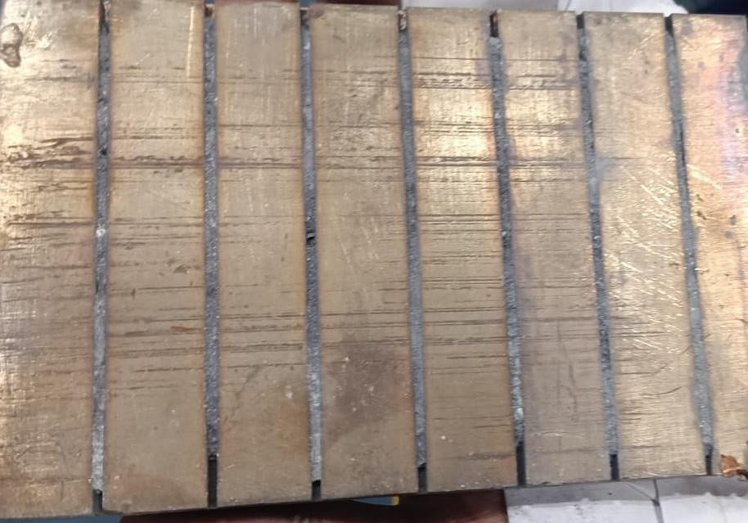
Figure 12 Specimen of Cu Plate with grooves

Tool used

A EN31 cylindrical tool profile in Figure 13 was machined with dimensions as specified in Figure 14 for the chosen processing technique. The component consists of a central cylindrical body with a diameter of 30 mm and a length of 30 mm, flanked by a broader shoulder section measuring 40 mm in diameter and 10 mm in thickness. This shoulder provides structural support and likely serves as a stop or positioning feature. At one end, the component tapers into a smaller cylindrical tip with a diameter of 5 mm, accompanied by a 45-degree chamfer to facilitate easy insertion or alignment in mating parts.
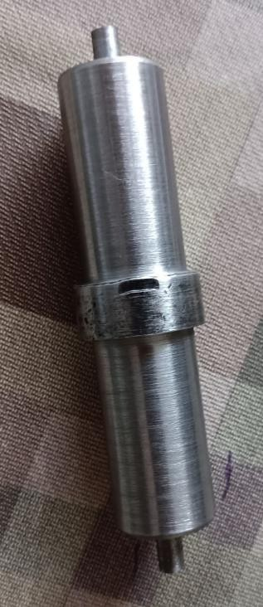

Figure 13 Fabricated Tool Profile

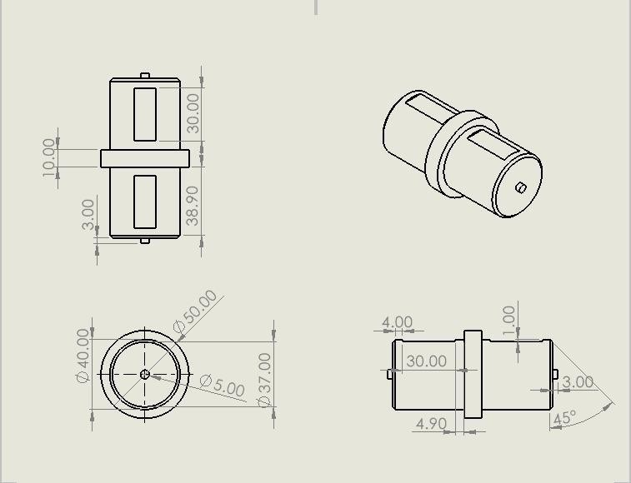
Shoulder
Cylindrical Tip

Figure 14 Dimensions of Tool

5.2 Sample Preparation

The preparation of the copper plate sample begins with a controlled heating process. The copper plate is placed inside a muffle furnace, as shown in Figure 15, where it is heated to a temperature of 249.2°C. This heating process is maintained for a duration of 60 minutes to ensure uniform thermal distribution throughout the copper plate. The purpose of preheating is to enhance the malleability of the copper and facilitate the subsequent friction stir processing (FSP).
After heating, the copper plate is carefully removed from the furnace. Due to its elevated temperature, special safety precautions are taken. Heat-resistant gloves and tongs are used to handle the hot plate and prevent any direct contact, thereby minimizing the risk of burns or injury. The heated plate is then transferred to the Friction Stir Processing (FSP) machine, as illustrated in Figure 16(a).
Once securely placed on the FSP setup, the friction stir processing begins. The FSP technique involves stirring the surface of the copper plate with a rotating tool under controlled parameters, which results in refined microstructure and improved mechanical properties. The process parameters are carefully selected to achieve optimal results, and the setup is adjusted accordingly.

First Pass
In the first pass of FSP, the copper plate is still approximately 245°C due to the residual heat from the furnace. At this temperature, the material is soft enough to facilitate smooth plastic deformation during processing. The traverse speed, which refers to the horizontal speed at which the tool moves along the plate, is set to 40 mm/min. Additionally, the spindle speed, or the rotational speed of the tool, is set at 1000 RPM (rotations per minute). These parameters ensure effective heat generation and plastic flow within the stirring zone.
As a result of this first pass, significant changes occur on the surface of the copper plate, enhancing its microstructure. This outcome is demonstrated in Figure 17(a), which highlights the uniformity and refinement achieved after the initial FSP pass.

Second Pass
For the second pass of FSP, the copper plate has cooled slightly and is now approximately 140°C. This reduced temperature affects the material’s flow properties, but the process is adjusted to maintain efficiency. The same traverse speed of 40 mm/min is used, ensuring consistent tool movement, while the spindle speed is lowered to 800 RPM. The reduction in spindle speed is designed to control the heat input and prevent overheating or excessive softening of the plate. The outcome of the second pass is presented in Figure 17(b).
Table 3 Process Parameters during FSP

Pass | Plate Temperature (°C) | Traverse Speed (mm/min) | Spindle Speed (RPM) | Result
First Pass | ~245°C | 40 mm/min | 1000 RPM | Shown in Fig 17(a)
Second Pass | ~140°C | 40 mm/min | 800 RPM | Shown in Fig 17(b)

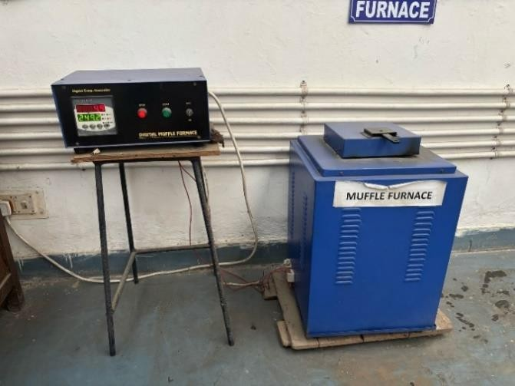
Figure 15 Muffle Furnace
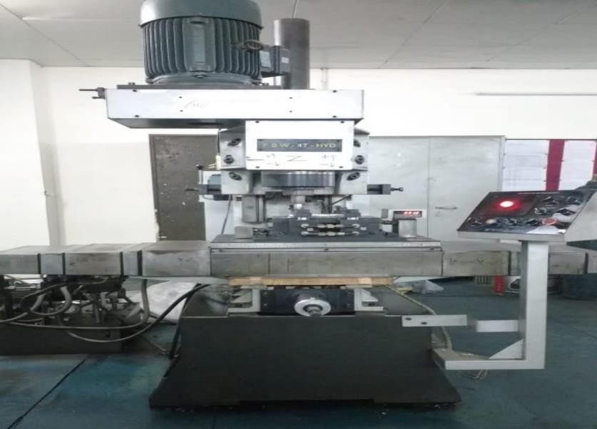
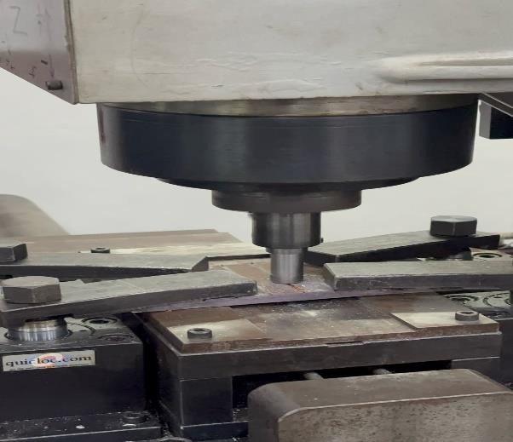
(a) Machine (b) During process
Figure 16 FSP Machine
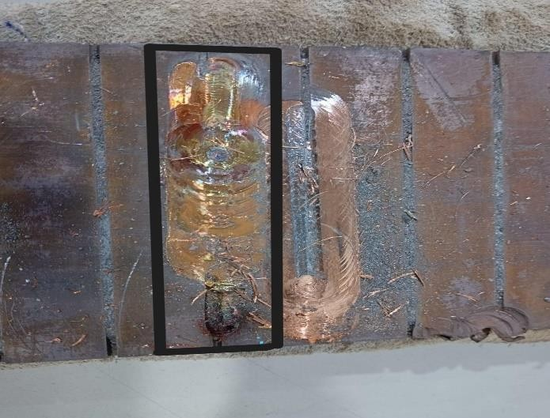
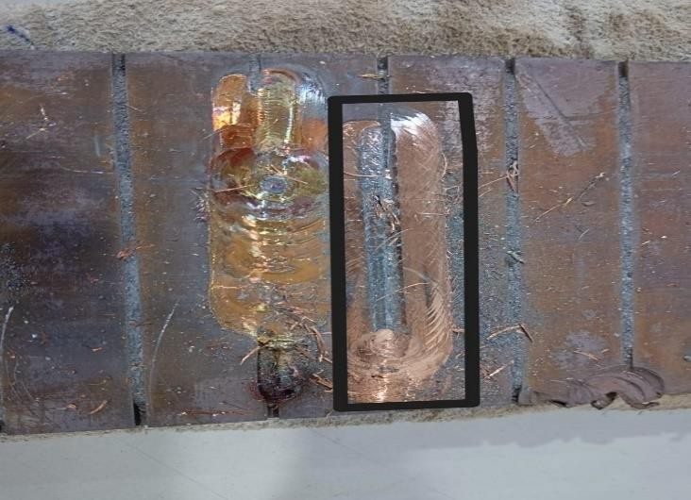
(a) 1st Pass (b) 2nd Pass
Figure 17 FSP Result

Research Plan

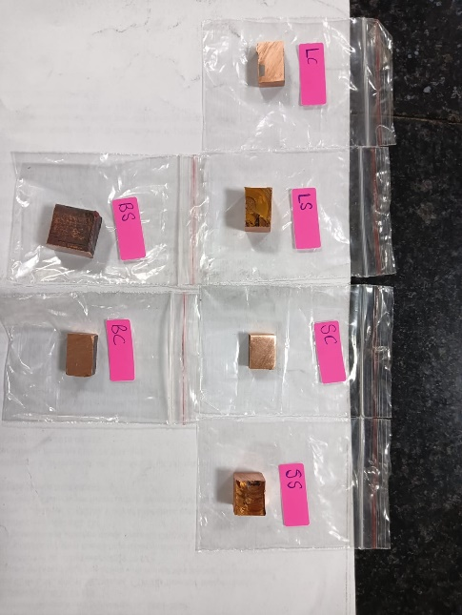
- We plan to study the microstructure of both the FSP prepared samples, named L and S for both the passes, and the base metal for comparison.

Figure 18 Prepared Samples labeled for microstructure

- We will study hardness values at both the surface and cross-section of the stir zone. Results of DMA is also in scope for study along with possibility of performing corrosion tests.
- We will also study the Wear characteristics of the prepared samples at both cross-section and surface, named ‘C’ and’S’ respectively for organization of samples.
- XRF and XRD results will also be attached for clear understanding of elemental distribution and their arrangement in the composite lattice.
- Given our time frame, possibility of attaching high-definition images captured using a FESEM is also possible to have better information regarding the surface characteristics of our samples.

References

- A. K. Sharma, R. Bhandari, A. Aherwar, and R. Rimašauskienė, “Matrix materials used in composites: A comprehensive study,” Mater. Today Proc., vol. 21, no. xxxx, pp. 1559–1562, 2020, doi: 10.1016/j.matpr.2019.11.086.
- M. F. Ashby et al., “Technology of the 1990s: advanced materials and predictive design,” Philos. Trans. R. Soc. London. Ser. A, Math. Phys. Sci., vol. 322, no. 1567, pp. 393–407, Jul. 1987, doi: 10.1098/rsta.1987.0059.
- “What is Metal Matrix Composite? | Advanced Composite.” https://advance- composite.co.jp/en/combine-two-or-morematerials/ (accessed Dec. 04, 2024).
- G. M. Kanaginahal, A. Kumar Muniraju, and M. Madhav Murthy, “Coatings for Enhancement of Properties of Polymer Matrix Composites: A review,” Mater. Today Proc., vol. 5, no. 1, pp. 2462–2465, 2018, doi: 10.1016/j.matpr.2017.11.026.
- S. H. Kamarudin et al., “A Review on Natural Fiber Reinforced Polymer Composites (NFRPC) for Sustainable Industrial Applications,” Polymers (Basel)., vol. 14, no. 17, p. 3698, Sep. 2022, doi: 10.3390/polym14173698.
- C. Bogiatzidis and L. Zoumpoulakis, “Thermoset Polymer Matrix Composites of Epoxy, Unsaturated Polyester, and Novolac Resin Embedding Construction and Demolition Wastes powder: A Comparative Study,” Polymers (Basel)., vol. 13, no. 5, p. 737, Feb. 2021, doi: 10.3390/polym13050737.
- A. . H. . A. J., D.; Pattnaik, “Polymer Matrix Composites with Improved Thermal Conductivity: A Review Lattice Boltzmann method View project Polymer Matrix Composites with Improved Thermal Conductivity: A Review,” J. Mater. Sci. Manuf. Technol., vol. 3, no. 3, 2019, [Online]. Available: https://www.researchgate.net/publication/335030072
- D. K. Rajak, D. D. Pagar, R. Kumar, and C. I. Pruncu, “Recent progress of reinforcement materials: a comprehensive overview of composite materials,” J. Mater. Res. Technol., vol. 8, no. 6, pp. 6354–6374, Nov. 2019, doi: 10.1016/j.jmrt.2019.09.068.
- Tanriverdiyev Yusif Alovsat, “Classification and properties of composites based on matrix material,” World J. Adv. Res. Rev., vol. 24, no. 2, pp. 2278–2282, Nov. 2024, doi:

10.30574/wjarr.2024.24.2.3608.

- D. Kopeliovich, “Advances in the manufacture of ceramic matrix composites using infiltration techniques,” in Advances in Ceramic Matrix Composites, Elsevier, 2014, pp. 79–108. doi: 10.1533/9780857098825.1.79.
- C. Zhang, “Understanding the wear and tribological properties of ceramic matrix composites,” in Advances in Ceramic Matrix Composites, Elsevier, 2014, pp. 312–339. doi: 10.1533/9780857098825.2.312.
- A. P. Divecha, S. G. Fishman, and S. D. Karmarkar, “Silicon Carbide Reinforced Aluminum—A Formable Composite,” JOM, vol. 33, no. 9, pp. 12–17, Sep. 1981, doi: 10.1007/BF03339487.
- S. Seetharaman and M. Gupta, “Fundamentals of Metal Matrix Composites,” in Encyclopedia of Materials: Composites, vol. 1, Elsevier, 2021, pp. 11–29. doi: 10.1016/B978-0-12-819724-0.00001-X.
- P. D. Pastuszak and A. Muc, “Application of Composite Materials in Modern Constructions,” Key Eng. Mater., vol. 542, pp. 119–129, Feb. 2013, doi: 10.4028/www.scientific.net/KEM.542.119.
- S. Bahl, “Fiber reinforced metal matrix composites - a review,” Mater. Today Proc., vol. 39, no. xxxx, pp. 317–323, 2021, doi: 10.1016/j.matpr.2020.07.423.
- J. M. Kunze and C. C. Bampton, “Challenges to Developing and Producing MMCs for Space Applications REINFORCED METAL,” Composites, 2001.
- M. L. Seleznev, J. D. Roy-Mayhew, and J. L. Faust, “Fabrication and tunable reinforcement of net-shaped aluminum matrix composite parts via 3D printing,” Sci. Rep., vol. 13, no. 1, p. 16334, Sep. 2023, doi: 10.1038/s41598-023-43514-y.
- Z. Ma, J. Bi, Y. Lu, H. Shen, and Y. Gao, “Abrasive wear of discontinuous SiC reinforced aluminum alloy composites,” Wear, vol. 148, no. 2, pp. 287–293, Aug. 1991, doi: 10.1016/0043-1648(91)90290-B.
- M. Shukla, S. K. Dhakad, P. Agarwal, and M. K. Pradhan, “Characteristic behaviour of aluminium metal matrix composites: A review,” Mater. Today Proc., vol. 5, no. 2, pp. 5830–5836, 2018, doi: 10.1016/j.matpr.2017.12.180.

- B. Das, S. Roy, R. N. Rai, and S. C. Saha, “Development of an in-situ synthesized multi- component reinforced Al–4.5%Cu–TiC metal matrix composite by FAS technique – Optimization of process parameters,” Eng. Sci. Technol. an Int. J., vol. 19, no. 1, pp. 279–291, Mar. 2016, doi: 10.1016/j.jestch.2015.08.002.
- R. V. Marode, T. A. Lemma, N. Sallih, S. R. Pedapati, M. Awang, and A. Hassan, “Research progress in friction stir processing of magnesium alloys and their metal matrix surface composites: Evolution in the 21st century,” J. Magnes. Alloy., vol. 12, no. 6, pp. 2091–2146, Jun. 2024, doi: 10.1016/j.jma.2024.06.007.
- B. R. Sunil, G. P. K. Reddy, H. Patle, and R. Dumpala, “Magnesium based surface metal matrix composites by friction stir processing,” J. Magnes. Alloy., vol. 4, no. 1, pp. 52– 61, Mar. 2016, doi: 10.1016/j.jma.2016.02.001.
- S. Seetharaman, J. Subramanian, R. A. Singh, W. L. E. Wong, M. L. S. Nai, and M. Gupta, “Mechanical Properties of Sustainable Metal Matrix Composites: A Review on the Role of Green Reinforcements and Processing Methods,” Technologies, vol. 10, no. 1, p. 32, Feb. 2022, doi: 10.3390/technologies10010032.
- O. Muribwathoho, V. Msomi, and S. Mabuwa, “Metal Matrix Composite Fabricated with 5000 Series Marine Grades of Aluminium Using FSP Technique: State of the Art Review,” Appl. Sci., vol. 12, no. 24, p. 12832, Dec. 2022, doi: 10.3390/app122412832.
- A. P. S. V. R. Subrahmanyam, G. Narsaraju, and B. S. Rao, “Effect of Rice Husk ash and Fly ash Reinforcements on Microstructure and Mechanical properties of Aluminium alloy (AlSi10Mg) Matrix Composites,” Int. J. Adv. Sci. Technol., vol. 76, pp. 1–8, Mar. 2015, doi: 10.14257/ijast.2015.76.01.
- R. Sekhar, D. Sharma, and P. Shah, “State of the Art in Metal Matrix Composites Research: A Bibliometric Analysis,” Appl. Syst. Innov., vol. 4, no. 4, p. 86, Nov. 2021, doi: 10.3390/asi4040086.
- S. Azeem Pasha and R. P. Reddy, “Fabrication of Surface MMC through Friction Stir Processing and Assessment of Machinability by EDM,” Int. Res. J. Eng. Technol., pp. 2395–0056, 2016.

- R. S. Mishra and Z. Y. Ma, “Friction stir welding and processing,” Mater. Sci. Eng. R Reports, vol. 50, no. 1–2, pp. 1–78, Aug. 2005, doi: 10.1016/j.mser.2005.07.001.
- M. Puviyarasan, L. Karthikeyan, C. Gnanavel, and K. Dhineshkumar, “A Critical review on friction stir based processes,” in Proceedings of the International Conference for Phoenixes on Emerging Current Trends in Engineering and Management (PECTEAM 2018), 2018, vol. 142, no. PECTEAM, pp. 258–266. doi: 10.2991/pecteam-18.2018.46.
- D. A. P. Prabhakar et al., “A comprehensive review of friction stir techniques in structural materials and alloys: challenges and trends,” J. Mater. Res. Technol., vol. 20,
pp. 3025–3060, Sep. 2022, doi: 10.1016/j.jmrt.2022.08.034.

- K. Palanikumar, E. Natarajan, S. Suresh, D. G. Mohan, C. Prakash, and K. Kaur, “Prospects of friction stir processed Mg alloys and composites-Reviews and suggestions,” J. Mater. Res. Technol., vol. 31, no. February, pp. 971–997, Jul. 2024, doi: 10.1016/j.jmrt.2024.06.087.
- R. Bauri and D. Yadav, “Processing Metal Matrix Composite (MMC) by FSP,” in Metal Matrix Composites by Friction Stir Processing, no. Mmc, Elsevier, 2018, pp. 31–55. doi: 10.1016/B978-0-12-813729-1.00003-6.
- R. S. Mishra, Z. Y. Ma, and I. Charit, “Friction stir processing: A novel technique for fabrication of surface composite,” Mater. Sci. Eng. A, vol. 341, no. 1–2, pp. 307–310, 2003, doi: 10.1016/S0921-5093(02)00199-5.
- M. R. Akbarpour et al., “An overview of friction stir processing of Cu–SiC composites: Microstructural, mechanical, tribological, and electrical properties,” J. Mater. Res. Technol., vol. 27, pp. 1317–1349, Nov. 2023, doi: 10.1016/j.jmrt.2023.09.200.
- M. Sabbaghian, M. Shamanian, H. R. Akramifard, and M. Esmailzadeh, “Effect of friction stir processing on the microstructure and mechanical properties of Cu–TiC composite,” Ceram. Int., vol. 40, no. 8, pp. 12969–12976, Sep. 2014, doi: 10.1016/j.ceramint.2014.04.158.
- M. Yang, C. Xu, C. Wu, K. Lin, Y. J. Chao, and L. An, “Fabrication of AA6061/Al2O3 nano ceramic particle reinforced composite coating by using friction stir processing,” J. Mater. Sci., vol. 45, no. 16, pp. 4431–4438, Aug. 2010, doi: 10.1007/s10853-010-4525-
1.

- G. Madhusudhan Reddy, A. Sambasiva Rao, and K. Srinivasa Rao, “Friction Stir Processing for Enhancement of Wear Resistance of ZM21 Magnesium Alloy,” Trans. Indian Inst. Met., vol. 66, no. 1, pp. 13–24, Feb. 2013, doi: 10.1007/s12666-012-0163-
1.

- M. Dixit, J. W. Newkirk, and R. S. Mishra, “Properties of friction stir-processed Al 1100- NiTi composite,” Scr. Mater., vol. 56, no. 6, pp. 541–544, 2007, doi: 10.1016/j.scriptamat.2006.11.006.
- R. K. Singh Yadav, V. Sharma, and B. Venkata Manoj Kumar, “On the role of sliding load and heat input conditions in friction stir processing on tribology of aluminium alloy– alumina surface composites,” Tribol. - Mater. Surfaces Interfaces, vol. 13, no. 2, pp. 88– 101, Apr. 2019, doi: 10.1080/17515831.2019.1591085.
- A. K. Kadian and P. Biswas, “Effect of tool pin profile on the material flow characteristics of AA6061,” J. Manuf. Process., vol. 26, pp. 382–392, Apr. 2017, doi: 10.1016/j.jmapro.2017.03.005.
- Y. N. Zhang, X. Cao, S. Larose, and P. Wanjara, “Review of tools for friction stir welding and processing,” Can. Metall. Q., vol. 51, no. 3, pp. 250–261, Jul. 2012, doi: 10.1179/1879139512Y.0000000015.
- I. Galvão, R. M. Leal, D. M. Rodrigues, and A. Loureiro, “Influence of tool shoulder geometry on properties of friction stir welds in thin copper sheets,” J. Mater. Process. Technol., vol. 213, no. 2, pp. 129–135, Feb. 2013, doi: 10.1016/j.jmatprotec.2012.09.01.
- B. R. Sunil, G. P. K. Reddy, H. Patle, and R. Dumpala, “Magnesium based surface metal matrix composites by friction stir processing,” J. Magnes. Alloy., vol. 4, no. 1, pp. 52– 61, Mar. 2016, doi: 10.1016/j.jma.2016.02.001.
- S. Seetharaman, J. Subramanian, R. A. Singh, W. L. E. Wong, M. L. S. Nai, and M. Gupta, “Mechanical Properties of Sustainable Metal Matrix Composites: A Review on the Role of Green Reinforcements and Processing Methods,” Technologies, vol. 10, no. 1, p. 32, Feb. 2022, doi: 10.3390/technologies10010032.
- O. Muribwathoho, V. Msomi, and S. Mabuwa, “Metal Matrix Composite Fabricated with 5000 Series Marine Grades of Aluminium Using FSP Technique: State of the Art Review,” Appl. Sci., vol. 12, no. 24, p. 12832, Dec. 2022, doi: 10.3390/app122412832.

- A. P. S. V. R. Subrahmanyam, G. Narsaraju, and B. S. Rao, “Effect of Rice Husk ash and Fly ash Reinforcements on Microstructure and Mechanical properties of Aluminium alloy (AlSi10Mg) Matrix Composites,” Int. J. Adv. Sci. Technol., vol. 76, pp. 1–8, Mar. 2015, doi: 10.14257/ijast.2015.76.01.
- R. Sekhar, D. Sharma, and P. Shah, “State of the Art in Metal Matrix Composites Research: A Bibliometric Analysis,” Appl. Syst. Innov., vol. 4, no. 4, p. 86, Nov. 2021, doi: 10.3390/asi4040086.
- S. Azeem Pasha and R. P. Reddy, “Fabrication of Surface MMC through Friction Stir Processing and Assessment of Machinability by EDM,” Int. Res. J. Eng. Technol., pp. 2395–0

- R. S. Mishra and Z. Y. Ma, “Friction stir welding and processing,” Mater. Sci. Eng. R Reports, vol. 50, no. 1–2, pp. 1–78, Aug. 2005, doi: 10.1016/j.mser.2005.07.001.
- M. Puviyarasan, L. Karthikeyan, C. Gnanavel, and K. Dhineshkumar, “A Critical review on friction stir based processes,” in Proceedings of the International Conference for Phoenixes on Emerging Current Trends in Engineering and Management (PECTEAM 2018), 2018, vol. 142, no. PECTEAM, pp. 258–266. doi: 10.2991/pecteam-18.2018.46.
- D. A. P. Prabhakar et al., “A comprehensive review of friction stir techniques in structural materials and alloys: challenges and trends,” J. Mater. Res. Technol., vol. 20,
pp. 3025–3060, Sep. 2022, doi: 10.1016/j.jmrt.2022.08.034.

- K. Palanikumar, E. Natarajan, S. Suresh, D. G. Mohan, C. Prakash, and K. Kaur, “Prospects of friction stir processed Mg alloys and composites-Reviews and suggestions,” J. Mater. Res. Technol., vol. 31, no. February, pp. 971–997, Jul. 2024, doi: 10.1016/j.jmrt.2024.06.087.
- R. Bauri and D. Yadav, “Processing Metal Matrix Composite (MMC) by FSP,” in Metal Matrix Composites by Friction Stir Processing, no. Mmc, Elsevier, 2018, pp. 31–55. doi: 10.1016/B978-0-12-813729-1.00003-6.
- R. S. Mishra, Z. Y. Ma, and I. Charit, “Friction stir processing: A novel technique for fabrication of surface composite,” Mater. Sci. Eng. A, vol. 341, no. 1–2, pp. 307–310, 2003, doi: 10.1016/S0921-5093(02)00199-5.

- M. R. Akbarpour et al., “An overview of friction stir processing of Cu–SiC composites: Microstructural, mechanical, tribological, and electrical properties,” J. Mater. Res. Technol., vol. 27, pp. 1317–1349, Nov. 2023, doi: 10.1016/j.jmrt.2023.09.200.
- M. Sabbaghian, M. Shamanian, H. R. Akramifard, and M. Esmailzadeh, “Effect of friction stir processing on the microstructure and mechanical properties of Cu–TiC composite,” Ceram. Int., vol. 40, no. 8, pp. 12969–12976, Sep. 2014, doi: 10.1016/j.ceramint.2014.04.158.
- M. Yang, C. Xu, C. Wu, K. Lin, Y. J. Chao, and L. An, “Fabrication of AA6061/Al2O3 nano ceramic particle reinforced composite coating by using friction stir processing,” J. Mater. Sci., vol. 45, no. 16, pp. 4431–4438, Aug. 2010, doi: 10.1007/s10853-010-4525-
1.

- G. Madhusudhan Reddy, A. Sambasiva Rao, and K. Srinivasa Rao, “Friction Stir Processing for Enhancement of Wear Resistance of ZM21 Magnesium Alloy,” Trans. Indian Inst. Met., vol. 66, no. 1, pp. 13–24, Feb. 2013, doi: 10.1007/s12666-012-0163-
2.

- M. Dixit, J. W. Newkirk, and R. S. Mishra, “Properties of friction stir-processed Al 1100- NiTi composite,” Scr. Mater., vol. 56, no. 6, pp. 541–544, 2007, doi: 10.1016/j.scriptamat.2006.11.006.
- R. K. Singh Yadav, V. Sharma, and B. Venkata Manoj Kumar, “On the role of sliding load and heat input conditions in friction stir processing on tribology of aluminium alloy– alumina surface composites,” Tribol. - Mater. Surfaces Interfaces, vol. 13, no. 2, pp. 88– 101, Apr. 2019, doi: 10.1080/17515831.2019.1591085.
- A. K. Kadian and P. Biswas, “Effect of tool pin profile on the material flow characteristics of AA6061,” J. Manuf. Process., vol. 26, pp. 382–392, Apr. 2017, doi: 10.1016/j.jmapro.2017.03.005.
- Y. N. Zhang, X. Cao, S. Larose, and P. Wanjara, “Review of tools for friction stir welding and processing,” Can. Metall. Q., vol. 51, no. 3, pp. 250–261, Jul. 2012, doi: 10.1179/1879139512Y.0000000015.
- I. Galvão, R. M. Leal, D. M. Rodrigues, and A. Loureiro, “Influence of tool shoulder geometry on properties of friction stir welds in thin copper sheets,” J. Mater. Process.

Technol., vol. 213, no. 2, pp. 129–135, Feb. 2013, doi: 10.1016/j.jmatprotec.2012.09.016.

- P. H. Shah and V. J. Badheka, “Friction stir welding of aluminium alloys: An overview of experimental findings – Process, variables, development and applications,” Proc. Inst. Mech. Eng. Part L J. Mater. Des. Appl., vol. 233, no. 6, pp. 1191–1226, Jun. 2019, doi: 10.1177/1464420716689588.
- S. Meshram and M. Reddy, “Influence of Tool Tilt Angle on Material Flow and Defect Generation in Friction Stir Welding of AA2219,” Def. Sci. J., vol. 68, no. 5, pp. 512– 518, Sep. 2018, doi: 10.14429/dsj.68.12027.
- R. Bauri and D. Yadav, “Introduction to Friction Stir Processing (FSP),” in Metal Matrix Composites by Friction Stir Processing, Elsevier, 2018, pp. 17–29. doi: 10.1016/B978-
0-12-813729-1.00002-4.

- M. Dadaei, H. Omidvar, B. Bagheri, M. Jahazi, and M. Abbasi, “The effect of SiC/Al 2 O 3 particles used during FSP on mechanical properties of AZ91 magnesium alloy,” Int.
J. Mater. Res., vol. 105, no. 4, pp. 369–374, Apr. 2014, doi: 10.3139/146.111025.

- . S. Mirjavadi et al., “Effect of multi-pass friction stir processing on the microstructure, mechanical and wear properties of AA5083/ZrO2 nanocomposites,” J. Alloys Compd., vol. 726, pp. 1262–1273, Dec. 2017, doi: 10.1016/j.jallcom.2017.08.084.
- J. Lipecka, M. Andrzejczuk, M. Lewandowska, J. Janczak-Rusch, and K. J. Kurzydłowski, “Evaluation of thermal stability of ultrafine grained aluminium matrix composites reinforced with carbon nanotubes,” Compos. Sci. Technol., vol. 71, no. 16,
pp. 1881–1885, Nov. 2011, doi: 10.1016/j.compscitech.2011.09.001.

- K. Zhao, Z. Liu, B. Xiao, and Z. Ma, “Friction stir welding of carbon nanotubes reinforced Al-Cu-Mg alloy composite plates,” J. Mater. Sci. Technol., vol. 33, no. 9, pp. 1004–1008, Sep. 2017, doi: 10.1016/j.jmst.2017.01.033.
- S. Raja, M. R. Muhamad, M. F. Jamaludin, and F. Yusof, “A review on nanomaterials reinforcement in friction stir welding,” J. Mater. Res. Technol., vol. 9, no. 6, pp. 16459– 16487, Nov. 2020, doi: 10.1016/j.jmrt.2020.11.072.
- T. A. Freeney and R. S. Mishra, “Effect of Friction Stir Processing on Microstructure and Mechanical Properties of a Cast-Magnesium–Rare Earth Alloy,” Metall. Mater. Trans. A, vol. 41, no. 1, pp. 73–84, Jan. 2010, doi: 10.1007/s11661-009-0080-2.

- A. R. Eivani, M. Mehdizade, M. Ghosh, and H. R. Jafarian, “The effect of multi-pass friction stir processing on microstructure, mechanical properties, and corrosion behavior of WE43-nHA bio-composite,” J. Mater. Res. Technol., vol. 22, pp. 776–794, Jan. 2023, doi: 10.1016/j.jmrt.2022.11.141.
- A. Samanta et al., “Microstructure-refinement–driven enhanced tensile properties of high-pressure die-cast A380 alloy through friction stir processing,” J. Manuf. Process., vol. 78, pp. 352–362, Jun. 2022, doi: 10.1016/j.jmapro.2022.04.027.
- N. Sun and D. Apelian, “Friction stir processing of aluminum cast alloys for high performance applications,” JOM, vol. 63, no. 11, pp. 44–50, Nov. 2011, doi:
10.1007/s11837-011-0190-3.

- T. A. Harris and R. M. Barnsby, “Life ratings for ball and roller bearings,” Proc. Inst. Mech. Eng. Part J J. Eng. Tribol., vol. 215, no. 6, pp. 577–595, Jun. 2001, doi: 10.1243/1350650011543817.
- F. Wardle, “Aerostatic bearings,” in Ultra-Precision Bearings, Elsevier, 2015, pp. 227–
306. doi: 10.1533/9780857092182.227.

- T. Lazović, A. Marinković, I. Atanasovska, M. Sedak, and B. Stojanović, “From Innovation to Standardization—A Century of Rolling Bearing Life Formula,” Machines, vol. 12, no. 7, p. 444, Jun. 2024, doi: 10.3390/machines12070444.
- D. Dowson and B. J. Hamrock, “History of ball bearings,” NASA Tech. Memo. 81689, p. 86, 1981, [Online]. Available: https://ntrs.nasa.gov/citations/19810009866
- W. Kwak, J. Lee, and Y.-B. Lee, “Theoretical and experimental approach to ball bearing frictional characteristics compared with cryogenic friction model and dry friction model,” Mech. Syst. Signal Process., vol. 124, pp. 424–438, Jun. 2019, doi: 10.1016/j.ymssp.2019.01.056.
- H. Zuo et al., “Performance enhancement of carbon/copper composites based on boron doping,” J. Alloys Compd., vol. 876, p. 160213, Sep. 2021, doi: 10.1016/j.jallcom.2021.160213.
- E. Hong, B. Kaplin, T. You, M. Suh, Y.-S. Kim, and H. Choe, “Tribological properties of copper alloy-based composites reinforced with tungsten carbide particles,” Wear, vol. 270, no. 9–10, pp. 591–597, Apr. 2011, doi: 10.1016/j.wear.2011.01.015.

- S. O. Akinwamide, O. J. Akinribide, and P. A. Olubambi, “Microstructural evolution, mechanical and nanoindentation studies of stir cast binary and ternary aluminium based composites,” J. Alloys Compd., vol. 850, p. 156586, Jan. 2021, doi: 10.1016/j.jallcom.2020.156586.
- A. O. Mosleh, E. G. Kotova, A. D. Kotov, I. S. Gershman, and A. E. Mironov, “Bearing Aluminum-Based Alloys: Microstructure, Mechanical Characterizations, and Experiment-Based Modeling Approach,” Materials (Basel)., vol. 15, no. 23, p. 8394, Nov. 2022, doi: 10.3390/ma15238394.
- Y. Pazhouhanfar and B. Eghbali, “Microstructural characterization and mechanical properties of TiB2 reinforced Al6061 matrix composites produced using stir casting process,” Mater. Sci. Eng. A, vol. 710, pp. 172–180, Jan. 2018, doi: 10.1016/j.msea.2017.10.08
- V. K. Sharma, V. Kumar, and R. S. Joshi, “Investigation of rare earth particulate on tribological and mechanical properties of Al-6061 alloy composites for aerospace application,” J. Mater. Res. Technol., vol. 8, no. 4, pp. 3504–3516, Jul. 2019, doi: 10.1016/j.jmrt.2019.06.025.
- P. P. Awate, S. B. Barve, P. Pesode, and S. S. Shinde, “Graphene/Al6061 nanocomposite for aerospace and automobile application,” Mater. Today Proc., Jul. 2023, doi: 10.1016/j.matpr.2023.07.075.
- B. Das, S. Roy, R. N. Rai, S. C. Saha, and P. Majumder, “Effect of in-situ processing parameters on microstructure and mechanical properties of TiC particulate reinforced Al–4.5Cu alloy MMC fabricated by stir-casting technique – Optimization using grey based differential evolution algorithm,” Measurement, vol. 93, pp. 397–408, Nov. 2016, doi: 10.1016/j.measurement.2016.07.044.
- T. Tamilanban and T. S. Ravikumar, “Influence of stirring speed on stir casting of SiC reinforced Al Mg Cu composite,” Mater. Today Proc., vol. 45, no. xxxx, pp. 5899–5902, 2021, doi: 10.1016/j.matpr.2020.08.633.
- K. Praveen Kumar, M. Gopi Krishna, J. Babu Rao, and N. R. M. R. Bhargava, “Fabrication and characterization of 2024 aluminium – High entropy alloy composites,”
J. Alloys Compd., vol. 640, no. 2015, pp. 421–427, Aug. 2015, doi: 10.1016/j.jallcom.2015.03.093.

- V. Krishna Mamidi et al., “Influence of titanium diboride reinforced magnesium composites using squeeze casting method,” Mater. Today Proc., no. xxxx, May 2023, doi: 10.1016/j.matpr.2023.04.602.
- K. N. P. Prasad and M. Ramachandra, “Determination of Abrasive Wear Behaviour of Al-Fly ash Metal Matrix Composites Produced by Squeeze Casting,” Mater. Today Proc., vol. 5, no. 1, pp. 2844–2853, 2018, doi: 10.1016/j.matpr.2018.01.075.
- V. Pandian and S. Kannan, “Effect of high entropy particle on aerospace-grade aluminium composite developed through combined mechanical supersonic vibration and squeeze infiltration technique,” J. Manuf. Process., vol. 74, no. July 2021, pp. 383–399, Feb. 2022, doi: 10.1016/j.jmapro.2021.12.024.
- M. R. Pattnayak, R. K. Pandey, and J. K. Dutt, “Performance behaviours of a self-acting gas journal bearing with a new bore design,” Tribol. Int., vol. 151, no. May, p. 106418,
Nov. 2020, doi: 10.1016/j.triboint.2020.106418.

- C.-S. Kim, K. Cho, M. H. Manjili, and M. Nezafati, “Mechanical performance of particulate-reinforced Al metal-matrix composites (MMCs) and Al metal-matrix nano- composites (MMNCs),” J. Mater. Sci., vol. 52, no. 23, pp. 13319–13349, Dec. 2017, doi: 10.1007/s10853-017-1378-x.
- V. R and K. H, “Analysing the characteristics of magnesium based composites for biomedical applications,” Mater. Today Proc., Mar. 2023, doi: 10.1016/j.matpr.2023.03.039.
- J. Woźniak, B. Adamczyk-Cieślak, M. Kostecki, K. Broniszewski, W. Bochniak, and A. Olszyna, “Influence of cooling condition on properties of extruded aluminum alloy matrix composites,” Compos. Part B Eng., vol. 77, pp. 100–104, Aug. 2015, doi: 10.1016/j.compositesb.2015.03.018.
- A. G. Kostornov and O. I. Fushchich, “Effects of Copper Powder Bearing Material Composition on Working Characteristics,” Powder Metall. Met. Ceram., vol. 44, no. 3– 4, pp. 202–206, Mar. 2005, doi: 10.1007/s11106-005-0081-7.
- L. Guirong et al., “Microstructural characteristics and mechanical behavior of microwave-assisted sintered ferromagnetic FeCoNi1.5CrCu HEAp/Al matrix composites,” J. Alloys Compd., vol. 861, p. 158439, Apr. 2021, doi: 10.1016/j.jallcom.2020.158439.

- S. Sharma, V. Patyal, P. Sudhakara, J. Singh, M. Petru, and R. A. Ilyas, “Mechanical, morphological, and fracture-deformation behavior of MWCNTs-reinforced (Al–Cu– Mg–T351) alloy cast nanocomposites fabricated by optimized mechanical milling and powder metallurgy techniques,” Nanotechnol. Rev., vol. 11, no. 1, pp. 65–85, Dec. 2021, doi: 10.1515/ntrev-2022-0005.
- J. Narayana Kamineni et al., “Investigation of the microstructure and mechanical properties of borosilicate reinforced magnesium nano composites,” Mater. Today Proc., no. xxxx, Jun. 2023, doi: 10.1016/j.matpr.2023.05.628.
- V. Pandian and S. Kannan, “Processing and preparation of aerospace-grade aluminium hybrid metal matrix composite in a modified stir casting furnace integrated with
mechanical supersonic vibration squeeze infiltration method,” Mater. Today Commun., vol. 26, no. September 2020, p. 101732, Mar. 2021, doi: 10.1016/j.mtcomm.2020.101732.
- J. Chen et al., “Fabrication and mechanical properties of AlCoNiCrFe high-entropy alloy particle reinforced Cu matrix composites,” J. Alloys Compd., vol. 649, pp. 630–634, Nov. 2015, doi: 10.1016/j.jallcom.2015.07.125.
- D. K. Koli, G. Agnihotri, and R. Purohit, “Advanced Aluminium Matrix Composites: The Critical Need of Automotive and Aerospace Engineering Fields,” Mater. Today Proc., vol. 2, no. 4–5, pp. 3032–3041, 2015, doi: 10.1016/j.matpr.2015.07.290.
- T. Futami, M. Ohira, H. Muto, and M. Sakai, “Indentation contact behavior of copper– graphite particulate composites: Correlation between the contact parameters and the electrical resistivity,” Carbon N. Y., vol. 46, no. 4, pp. 671–678, Apr. 2008, doi: 10.1016/j.carbon.2008.01.023.
- C. M C et al., “Microstructural Modification, Mechanical Properties, and Wear Behaviour of Aged Al-Si-Mg/Si3N4 Composites for Aerospace Applications,” Int. J. Light. Mater. Manuf., Jul. 2024, doi: 10.1016/j.ijlmm.2024.07.005.
- Z. Yuan et al., “Effect of heat treatment on the interface of high-entropy alloy particles reinforced aluminum matrix composites,” J. Alloys Compd., vol. 822, no. 2020, p. 153658, May 2020, doi: 10.1016/j.jallcom.2020.153658.
- Y. Liu, J. Chen, J. Liu, P. Zhang, and Y. Wang, “Core-shell structure mediated

microstructure and mechanical properties of high entropy alloy CoCrFeNi/Al composites,” Vacuum, vol. 192, no. May, p. 110454, Oct. 2021, doi: 10.1016/j.vacuum.2021.110454.
- Z. Yuan, W. Tian, F. Li, Q. Fu, Y. Hu, and X. Wang, “Microstructure and properties of high-entropy alloy reinforced aluminum matrix composites by spark plasma sintering,”
J. Alloys Compd., vol. 806, no. 2019, pp. 901–908, Oct. 2019, doi: 10.1016/j.jallcom.2019.07.185.
- S. Li, Y. Li, H. Guo, Z. Wen, and Z. Zhu, “Effect of electromagnetic stirring frequency on tribological performance and corrosion resistance of Al-Sn bearing alloy,” Mater. Today Commun., vol. 32, no. May, p. 103898, Aug. 2022, doi:
10.1016/j.mtcomm.2022.103898.

- A. Kumar, V. Kumar, A. Kumar, B. Nahak, and R. Singh, “Investigation of mechanical and tribological performance of marble dust 7075 aluminium alloy composites,” Mater. Today Proc., vol. 44, pp. 4542–4547, 2021, doi: 10.1016/j.matpr.2020.10.812.
- M. C. Lucchetta, F. Saporiti, and F. Audebert, “Improvement of surface properties of an Al–Sn–Cu plain bearing alloy produced by rapid solidification,” J. Alloys Compd., vol. 805, pp. 709–717, Oct. 2019, doi: 10.1016/j.jallcom.2019.07.082.
- T. Iwata et al., “Excellent Seizure and Friction Properties Achieved with a Combination of an a-C:H:Si DLC-Coated Journal and an Aluminum Alloy Plain Bearing,” Coatings, vol. 11, no. 9, p. 1055, Aug. 2021, doi: 10.3390/coatings11091055.
- S. N. Alhajeri, K. J. Al-Fadhalah, A. I. Almazrouee, and T. G. Langdon, “Microstructure and microhardness of an Al-6061 metal matrix composite processed by high-pressure torsion,” Mater. Charact., vol. 118, pp. 270–278, Aug. 2016, doi: 10.1016/j.matchar.2016.06.003.
- Y. Pan, G. Wu, Z. Huang, X. Wu, Y. Liu, and H. Ye, “Corrosion behaviour of carbon fibre reinforced polymer/magnesium alloy hybrid laminates,” Corros. Sci., vol. 115, pp. 152–158, Feb. 2017, doi: 10.1016/j.corsci.2016.11.022.
- X. Hao, H. Nie, Z. Ye, Y. Luo, L. Zheng, and W. Liang, “Mechanical properties of a novel fiber metal laminate based on a carbon fiber reinforced Zn-Al alloy composite,” Mater. Sci. Eng. A, vol. 740–741, pp. 218–225, Jan. 2019, doi:

10.1016/j.msea.2018.10.050.

- R. Jamaati and M. R. Toroghinejad, “Fabrication of MMC Strip by CRB Process,” J. Mater. Eng. Perform., vol. 21, no. 6, pp. 859–864, Jun. 2012, doi: 10.1007/s11665-011-
9909-0.

- V. S. Aigbodion, A. A. Alayyaf, and C. J. Ozoude, “Understanding the anti-corrosion characteristics of surface modification of h-BN and carbon nanotubes/magnesium composites in simulated seawater,” RSC Adv., vol. 14, no. 33, pp. 24152–24164, 2024, doi: 10.1039/D4RA04076G.
- A. Deshpande, A. Tofangchi, and K. Hsu, “Microstructure evolution of Al6061 and copper during ultrasonic energy assisted compression,” Mater. Charact., vol. 153, pp.
240–250, Jul. 2019, doi: 10.1016/j.matchar.2019.05.005.

- P. R. Subramanian, S. Krishnamurthy, S. T. Keller, and M. G. Mendiratta, “Processing of continuously reinforced Ti-alloy metal matrix composites (MMC) by magnetron sputtering,” Mater. Sci. Eng. A, vol. 244, no. 1, pp. 1–10, Mar. 1998, doi: 10.1016/S0921- 5093(97)00820-4.
- R. . Mishra, M. . Mahoney, S. . McFadden, N. . Mara, and A. . Mukherjee, “High strain rate superplasticity in a friction stir processed 7075 Al alloy,” Scr. Mater., vol. 42, no. 2,
pp. 163–168, Dec. 1999, doi: 10.1016/S1359-6462(99)00329-2.

- K. E. C. Vidyasagar, R. K. Pandey, and D. Kalyanasundaram, “Improvement of Deep Groove Ball Bearing’s Performance Using a Bionic Textured Inner Race,” J. Bionic Eng., vol. 18, no. 4, pp. 974–990, Jul. 2021, doi: 10.1007/s42235-021-0056-5.
- N. C. Ramgopal, S. Seetharaman, C. Balamurugan, and D. Pal, “Optimization of wear characteristics on boron carbide/flyash reinforced aluminum alloy (7000 series) hybrid composites,” Mater. Today Proc., vol. 69, pp. 654–657, 2022, doi: 10.1016/j.matpr.2022.06.546.
- A. Shafiei-Zarghani, S. F. Kashani-Bozorg, and A. Zarei-Hanzaki, “Microstructures and mechanical properties of Al/Al2O3 surface nano-composite layer produced by friction stir processing,” Mater. Sci. Eng. A, vol. 500, no. 1–2, pp. 84–91, Jan. 2009, doi: 10.1016/j.msea.2008.09.064.
- G. M. Gençer, “Sn/Graphite/Cu reinforced aluminum: An experimental study on

fabrication of hybrid surface composite as journal bearing material by friction stir processing,” J. Alloys Compd., vol. 1002, p. 175445, Oct. 2024, doi: 10.1016/j.jallcom.2024.175445.
- H. Sarmadi, A. H. Kokabi, and S. M. Seyed Reihani, “Friction and wear performance of copper–graphite surface composites fabricated by friction stir processing (FSP),” Wear, vol. 304, no. 1–2, pp. 1–12, Jul. 2013, doi: 10.1016/j.wear.2013.04.023.
- A. Maqbool and N. Z. Khan, “Fabrication and characterization of hybrid WE43 Mg alloy-based composite by friction stir processing with improved ductility,” Vacuum, vol. 215, no. May, p. 112273, Sep. 2023, doi: 10.1016/j.vacuum.2023.112273.

- A. K. P., D. Yadav, C. S. Perugu, and S. V. Kailas, “Influence of particulate reinforcement on microstructure evolution and tensile properties of in-situ polymer derived MMC by friction stir processing,” Mater. Des., vol. 113, pp. 99–108, Jan. 2017, doi: 10.1016/j.matdes.2016.09.101.
- S. Li et al., “Development and applications of aluminum alloys for aerospace industry,”
J. Mater. Res. Technol., vol. 27, pp. 944–983, Nov. 2023, doi: 10.1016/j.jmrt.2023.09.274.
- K. Kumar Jha, R. Kesharwani, and M. Imam, “Microstructural and micro-hardness study on the fabricated Al 5083-O/6061-T6/7075-T6 gradient composite component via a novel route of friction stir additive manufacturing,” Mater. Today Proc., vol. 56, pp. 819–825, 2022, doi: 10.1016/j.matpr.2022.02.262.
- L. Zhou et al., “Comparison of different optimization techniques for microwave-assisted biodiesel production,” Energy Sources, Part A Recover. Util. Environ. Eff., vol. 00, no. 00, pp. 1–17, 2020, doi: 10.1080/15567036.2020.1851324.
- T. Sathish, L. Kamaraj, V. Mohanavel, Y. Jazaa, F. Qahtani, and S. Althahban, “A novel technique implementation to fabricate and analysis of AZ91D with TiN through FSP,” Int. J. Adv. Manuf. Technol., no. 0123456789, Jul. 2023, doi: 10.1007/s00170-023- 12024-6.
- P. Kurtyka, N. Rylko, T. Tokarski, A. Wójcicka, and A. Pietras, “Cast aluminium matrix composites modified with using FSP process – Changing of the structure and mechanical properties,” Compos. Struct., vol. 133, pp. 959–967, Dec. 2015, doi:

10.1016/j.compstruct.2015.07.122.

- R. Dhayalan, K. Kalaiselvan, and R. Sathiskumar, “Characterization of AA6063/SiC-Gr surface composites produced by FSP technique,” Procedia Eng., vol. 97, pp. 625–631, 2014, doi: 10.1016/j.proeng.2014.12.291.
- V. K. S. Jain, K. U. Yazar, and S. Muthukumaran, “Development and characterization of Al5083-CNTs/SiC composites via friction stir processing,” J. Alloys Compd., vol. 798,
pp. 82–92, Aug. 2019, doi: 10.1016/j.jallcom.2019.05.232.

- B. Bagheri and M. Abbasi, “Development of AZ91/SiC surface composite by FSP: effect of vibration and process parameters on microstructure and mechanical characteristics,”
Adv. Manuf., vol. 8, no. 1, pp. 82–96, 2020, doi: 10.1007/s40436-019-00288-9.

- R. Bauri, D. Yadav, and G. Suhas, “Effect of friction stir processing (FSP) on microstructure and properties of Al–TiC in situ composite,” Mater. Sci. Eng. A, vol. 528, no. 13–14, pp. 4732–4739, May 2011, doi: 10.1016/j.msea.2011.02.085.
- L. Tonelli et al., “Effect of FSP parameters and tool geometry on microstructure, hardness, and wear properties of AA7075 with and without reinforcing B4C ceramic particles,” Int. J. Adv. Manuf. Technol., vol. 102, no. 9–12, pp. 3945–3961, Jun. 2019, doi: 10.1007/s00170-019-03442-6.
- L. S. Raju and A. Kumar, “A Novel Approach for Fabrication of Cu-Al2O3 Surface Composites by Friction Stir Processing,” Procedia Mater. Sci., vol. 5, pp. 434–443, 2014, doi: 10.1016/j.mspro.2014.07.286.
- M. Regev and S. Spigarelli, “A Study of the Metallurgical and Mechanical Properties of Friction-Stir-Processed Cu,” Metals (Basel)., vol. 11, no. 4, p. 656, Apr. 2021, doi: 10.3390/met11040656.
- A. Heidarzadeh, H. Pouraliakbar, S. Mahdavi, and M. R. Jandaghi, “Ceramic nanoparticles addition in pure copper plate: FSP approach, microstructure evolution and

texture study using EBSD,” Ceram. Int., vol. 44, no. 3, pp. 3128–3133, Feb. 2018, doi: 10.1016/j.ceramint.2017.11.080.
- M.-N. Avettand-Fènoël, A. Simar, R. Shabadi, R. Taillard, and B. de Meester, “Characterization of oxide dispersion strengthened copper based materials developed by friction stir processing,” Mater. Des., vol. 60, pp. 343–357, Aug. 2014, doi: 10.1016/j.matdes.2014.04.012.
- S. P. Dwivedi and S. Sharma, “Development and characterization of Cu-Ni- Al2O3 surface composite developed by friction stir process technique,” Mater. Today Commun.,
vol. 37, no. October, p. 107399, Dec. 2023, doi: 10.1016/j.mtcomm.2023.107399.

- K. Surekha and A. Els-Botes, “Development of high strength, high conductivity copper by friction stir processing,” Mater. Des., vol. 32, no. 2, pp. 911–916, Feb. 2011, doi: 10.1016/j.matdes.2010.08.028.
- J.-Q. Su, T. W. Nelson, T. R. McNelley, and R. S. Mishra, “Development of nanocrystalline structure in Cu during friction stir processing (FSP),” Mater. Sci. Eng. A, vol. 528, no. 16–17, pp. 5458–5464, Jun. 2011, doi: 10.1016/j.msea.2011.03.043.
- T. Thankachan, K. S. Prakash, and V. Kavimani, “Effect of friction stir processing and hybrid reinforcements on copper,” Mater. Manuf. Process., vol. 33, no. 15, pp. 1681– 1692, Nov. 2018, doi: 10.1080/10426914.2018.1453149.
- M. Sabbaghian, M. Shamanian, H. R. Akramifard, and M. Esmailzadeh, “Effect of friction stir processing on the microstructure and mechanical properties of Cu–TiC composite,” Ceram. Int., vol. 40, no. 8, pp. 12969–12976, Sep. 2014, doi: 10.1016/j.ceramint.2014.04.158.
- R. M. Leal, I. Galvão, A. Loureiro, and D. M. Rodrigues, “Effect of friction stir processing parameters on the microstructural and electrical properties of copper,” Int. J. Adv. Manuf. Technol., vol. 80, no. 9–12, pp. 1655–1663, Oct. 2015, doi: 10.1007/s00170- 015-7141-z.
- M. Pezeshkian, I. Ebrahimzadeh, and F. Gharavi, “Fabrication of Cu Surface Composite Reinforced by Ni Particles Via Friction Stir Processing: Microstructure and Tribology Behaviors,” J. Tribol., vol. 140, no. 1, Jan. 2018, doi: 10.1115/1.4037069.
- J. Jafari, M. K. B. Givi, and M. Barmouz, “Mechanical and microstructural

characterization of Cu/CNT nanocomposite layers fabricated via friction stir processing,” Int. J. Adv. Manuf. Technol., vol. 78, no. 1–4, pp. 199–209, Apr. 2015, doi: 10.1007/s00170-014-6663-0.
- H. R. Akramifard, M. Shamanian, M. Sabbaghian, and M. Esmailzadeh, “Microstructure and mechanical properties of Cu/SiC metal matrix composite fabricated via friction stir processing,” Mater. Des., vol. 54, pp. 838–844, Feb. 2014, doi: 10.1016/j.matdes.2013.08.107.
- P. Xue, B. B. Wang, F. F. Chen, W. G. Wang, B. L. Xiao, and Z. Y. Ma, “Microstructure and mechanical properties of friction stir processed Cu with an ideal ultrafine-grained structure,” Mater. Charact., vol. 121, pp. 187–194, Nov. 2016, doi: 10.1016/j.matchar.2016.10.009.
- R. Zhu, Y. Li, Y. Sun, J. Feng, and W. Gong, “Microstructure and properties of FeCoNiCrAl high-entropy alloy particle-reinforced Cu-matrix composites prepared via FSP,” J. Alloys Compd., vol. 940, p. 168906, Apr. 2023, doi: 10.1016/j.jallcom.2023.168906.
- J.-Q. Su, T. W. Nelson, T. R. McNelley, and R. S. Mishra, “Development of nanocrystalline structure in Cu during friction stir processing (FSP),” Mater. Sci. Eng. A, vol. 528, no. 16–17, pp. 5458–5464, Jun. 2011, doi: 10.1016/j.msea.2011.03.043.
- M. Barmouz, M. K. Besharati Givi, and J. Seyfi, “On the role of processing parameters in producing Cu/SiC metal matrix composites via friction stir processing: Investigating microstructure, microhardness, wear and tensile behavior,” Mater. Charact., vol. 62, no. 1, pp. 108–117, Jan. 2011, doi: 10.1016/j.matchar.2010.11.005.
- H. Kumar, R. Prasad, A. Srivastava, M. Vashista, and M. Z. Khan, “Utilisation of industrial waste (Fly ash) in synthesis of copper based surface composite through friction stir processing route for wear applications,” J. Clean. Prod., vol. 196, pp. 460–468, Sep. 2018, doi: 10.1016/j.jclepro.2018.06.029.
- S. Swaminathan et al., “Peak Stir Zone Temperatures during Friction Stir Processing,” Metall. Mater. Trans. A, vol. 41, no. 3, pp. 631–640, Mar. 2010, doi: 10.1007/s11661- 009-0140-7.
- H. Torabmostaedi, T. Zhang, P. Foot, S. Dembele, and C. Fernandez, “Process control for the synthesis of ZrO2 nanoparticles using FSP at high production rate,” Powder Technol., vol. 246, pp. 419–433, Sep. 2013, doi: 10.1016/j.powtec.2013.05.006.
- P. Asadi, G. Faraji, and M. K. Besharati, “Producing of AZ91/SiC composite by friction stir processing (FSP),” Int. J. Adv. Manuf. Technol., vol. 51, no. 1–4, pp. 247–260, Nov. 2010, doi: 10.1007/s00170-010-2600-z.
- K. H. Raj, R. S. Sharma, P. Singh, and A. Dayal, “Study of friction stir processing (FSP) and high pressure torsion (HPT) and their effect on mechanical properties,” Procedia Eng., vol. 10, pp. 2904–2910, 2011, doi: 10.1016/j.proeng.2011.04.482.
- V. Sharma, U. Prakash, and B. V. M. Kumar, “Surface composites by friction stir processing: A review,” J. Mater. Process. Technol., vol. 224, pp. 117–134, Oct. 2015, doi: 10.1016/j.jmatprotec.2015.04.019
- J. Iwaszko, K. Kudła, K. Fila, and M. Strzelecka, “The Effect of Friction Stir Processing (FSP) on the Microstructure and Properties of AM60 Magnesium Alloy,” Arch. Metall. Mater., vol. 61, no. 3, pp. 1555–1560, Sep. 2016, doi: 10.1515/amm-2016-0254.
- S. Mabuwa and V. Msomi, “The effect of FSP conditions towards microstructure and mechanical properties of the AA6082/AA8011 TIG-welded joint,” Mater. Res. Express, vol. 8, no. 6, p. 066514, Jun. 2021, doi: 10.1088/2053-1591/ac0735.
- M. Abbasi, B. Bagheri, M. Dadaei, H. R. Omidvar, and M. Rezaei, “The effect of FSP on mechanical, tribological, and corrosion behavior of composite layer developed on magnesium AZ91 alloy surface,” Int. J. Adv. Manuf. Technol., vol. 77, no. 9–12, pp. 2051–2058, Apr. 2015, doi: 10.1007/s00170-014-6577-x.
- M. Høj, D. K. Pham, M. Brorson, L. Mädler, A. D. Jensen, and J.-D. Grunwaldt, “Two- Nozzle Flame Spray Pyrolysis (FSP) Synthesis of CoMo/Al2O3 Hydrotreating Catalysts,” Catal. Letters, vol. 143, no. 5, pp. 386–394, May 2013, doi: 10.1007/s10562- 013-0990-x.
- M. Høj, D. K. Pham, M. Brorson, L. Mädler, A. D. Jensen, and J.-D. Grunwaldt, “Two- Nozzle Flame Spray Pyrolysis (FSP) Synthesis of CoMo/Al2O3 Hydrotreating Catalysts,” Catal. Letters, vol. 143, no. 5, pp. 386–394, May 2013, doi: 10.1007/s10562- 013-0990-x.
- J. Iwaszko and K. Kudła, “Effect of friction stir processing (FSP) on microstructure and hardness of AlMg10/SiC composite,” Bull. Polish Acad. Sci. Tech. Sci., vol. 67, no. 2,
pp. 185–192, Feb. 2019, doi: 10.24425/bpas.2019.126530.

- R. Zhu, Y. Li, Y. Sun, J. Feng, and W. Gong, “Microstructure and properties of FeCoNiCrAl high-entropy alloy particle-reinforced Cu-matrix composites prepared via FSP,” J. Alloys Compd., vol. 940, p. 168906, Apr. 2023, doi: 10.1016/j.jallcom.2023.168906.
- M. Barmouz, M. K. Besharati Givi, and J. Seyfi, “On the role of processing parameters in producing Cu/SiC metal matrix composites via friction stir processing: Investigating microstructure, microhardness, wear and tensile behavior,” Mater. Charact., vol. 62, no. 1, pp. 108–117, Jan. 2011, doi: 10.1016/j.matchar.2010.11.005.
- H. Kumar, R. Prasad, A. Srivastava, M. Vashista, and M. Z. Khan, “Utilisation of industrial waste (Fly ash) in synthesis of copper based surface composite through friction stir processing route for wear applications,” J. Clean. Prod., vol. 196, pp. 460–468, Sep. 2018, doi: 10.1016/j.jclepro.2018.06.029.
- S. Cartigueyen and K. Mahadevan, “Wear characteristics of copper-based surface-level microcomposites and nanocomposites prepared by friction stir processing,” Friction, vol. 4, no. 1, pp. 39–49, Mar. 2016, doi: 10.1007/s40544-016-0102-1

